Ahmad El Jazaerli

Laila Monzer

EECE 435L Project

Smart Meeting Room & Management System Backend



Introduction — Implemented by Laila Monzer 5

System Architecture — Implemented by Ahmad Jazaerli 5

Part I Tasks 6

Implementation Details 6

5.1 Service 1: Users — Implemented by Laila Monzer 6

5.2 Service 2: Rooms — Implemented by Ahmad Jazaerli 12

5.3 Service 3: Bookings — Implemented by Laila Monzer 18

5.4 Service 4: Reviews — Implemented by Ahmad Jazaerli 26

Database Design — Implemented by Both (Laila: Schema, Ahmad: Relationships) 33

Error Handling and Validation — Implemented by Laila Monzer 35

Testing — Implemented by Ahmad Jazaerli 38

Deployment and Integration — Implemented by Both (Laila: Dockerfiles, Ahmad: docker-compose.yml) 44

Documentation and Profiling — Implemented by Laila Monzer 45

GitHub and Version Control — Implemented by Ahmad Jazaerli 48

Docker and Images — Implemented by Both (Laila: Build, Ahmad: Run) 49

Validation and Sanitization — Implemented by Laila Monzer 51

User Authentication — Implemented by Ahmad Jazaerli 53

Moderation — Implemented by Laila Monzer 56

Part II Tasks 59

16.1.1 Enhanced Inter-Service Communication — Laila Monzer 59

Circuit Breaker Pattern 59

Rate Limiting and Throttling 60

16.1.2-Scalability and Reliability — Laila Monzer 61

Health Checks 61

Horizontal Scaling 63

Asynchronous Messaging (RabbitMQ) 65

16.2.1-Advanced Security Measures – Ahmad Jazaerli 66

Auditing and Logging 66

Secure Configuration Management 68

16.2.2- Performance Optimization – Ahmad Jazaerli 68

Database Indexing 68

Caching Mechanism 69

Load Balancing (Nginx) 70

Database Indexing 72

17.Conclusion 73

18.References 73

# Introduction — Implemented by Laila Monzer

The Smart Meeting Room & Management System is a backend solution designed to facilitate the process of booking, managing, and reviewing meeting rooms within an organization. This system consists of four microservices: Users, Rooms, Bookings, and Reviews that communicate through APIs. The primary goal was to create a scalable, secure, and resilient backend that can handle real-world usage patterns, including concurrent bookings, user authentication, and room availability checks.

Our project influences modern software engineering practices, including containerization with Docker, API testing with Postman, unit testing with Pytest, and documentation with Sphinx. We also implemented advanced features such as circuit breakers, rate limiting, horizontal scaling, and asynchronous messaging to enhance system reliability and performance and more .

As a team of two, we divided the work evenly, with each member responsible for two core services and two or more Part II enhancements. This ensured that both members contributed equally to the project’s success and met all requirements outlined in the Zero-Tolerance Checklist.

# System Architecture — Implemented by Ahmad Jazaerli

The system architecture is based on a microservices pattern, where each service operates independently and communicates with others through HTTP APIs. The four core services are:

A-Users Service: Manages user accounts, authentication, and authorization. It handles user registration, login, profile updates, and role-based access control.

B-Rooms Service: Manages meeting room details, including capacity, equipment, location, and availability. It allows users to search for and book rooms based on specific and desired criteria.

C-Bookings Service: Handles the creation, modification, and cancellation of room bookings. It ensures that bookings are valid (i.e., the room is available at the requested time) and stores the booking ‘s history for each user.

D-Reviews Service: Allows users to submit, update, and delete reviews for meeting rooms. It also includes moderation features to handle inappropriate content. All services are containerized using Docker and run on separate ports. A PostgreSQL database is used to store all data, and RabbitMQ is used for asynchronous communication between services. The services are orchestrated using Docker Compose, which allows for easy scaling and deployment.

The architecture is designed to be scalable and fault-tolerant, with health checks, circuit breakers, and rate limiting implemented to ensure system stability under load. Additionally, detailed logging and monitoring are in place to facilitate debugging and operational management.

# Part I Tasks

## Implementation Details

### 5.1 Service 1: Users — Implemented by Laila Monzer

The Users service is responsible for managing user accounts and authentication. It implements the following APIs:

A-User Registration: Allows new users to create an account by providing their name, username, password, email, and role. The service validates the input and stores the user in the database.

B-User Login: Authenticates users by verifying their username and password. Upon successful login, the service returns a Bearer token for subsequent requests.

C-Update User Details: Allows users to update their profile information, such as name, email, or password.

D-Delete User Account: Allows users to delete their account. This action is irreversible and requires confirmation.

E-Get Users: Retrieves a list of all users or a specific user by username. This endpoint is accessible only to Admin users.

F-View Booking History: Retrieves the booking history for a specific user. This endpoint is accessible to the user themselves and to Admin users. The service supports multiple user roles (Admin, Regular User, Facility Manager, Moderator) and enforces role-based access control (RBAC) for all operations. For example, only Admin users can create or delete other users, while Regular Users can only manage their own profile and view their booking history.

Postman Collection: The screenshot below shows the Postman collection for the Users service, with all endpoints documented and tested. Each request includes a description and comments for the fields.

Figure 5.2: User Registration Test in Postman — Laila Monzer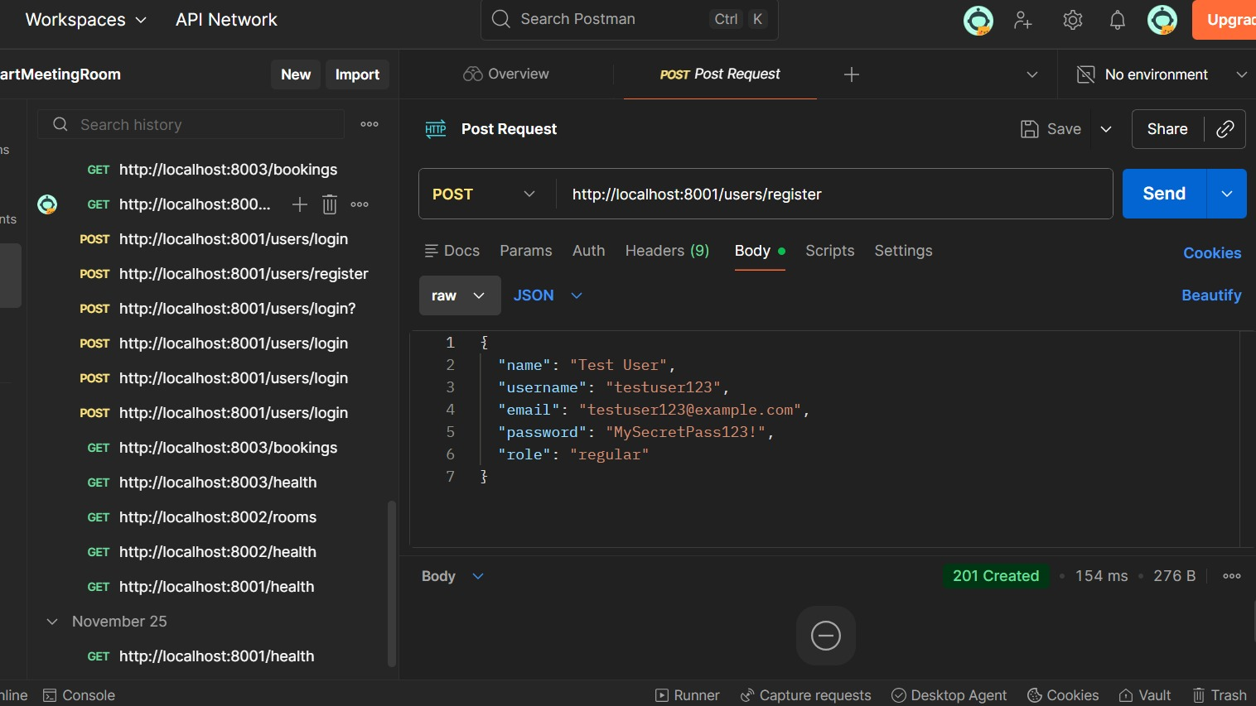

Figure 5.3: User Login Test in Postman — Laila Monzer

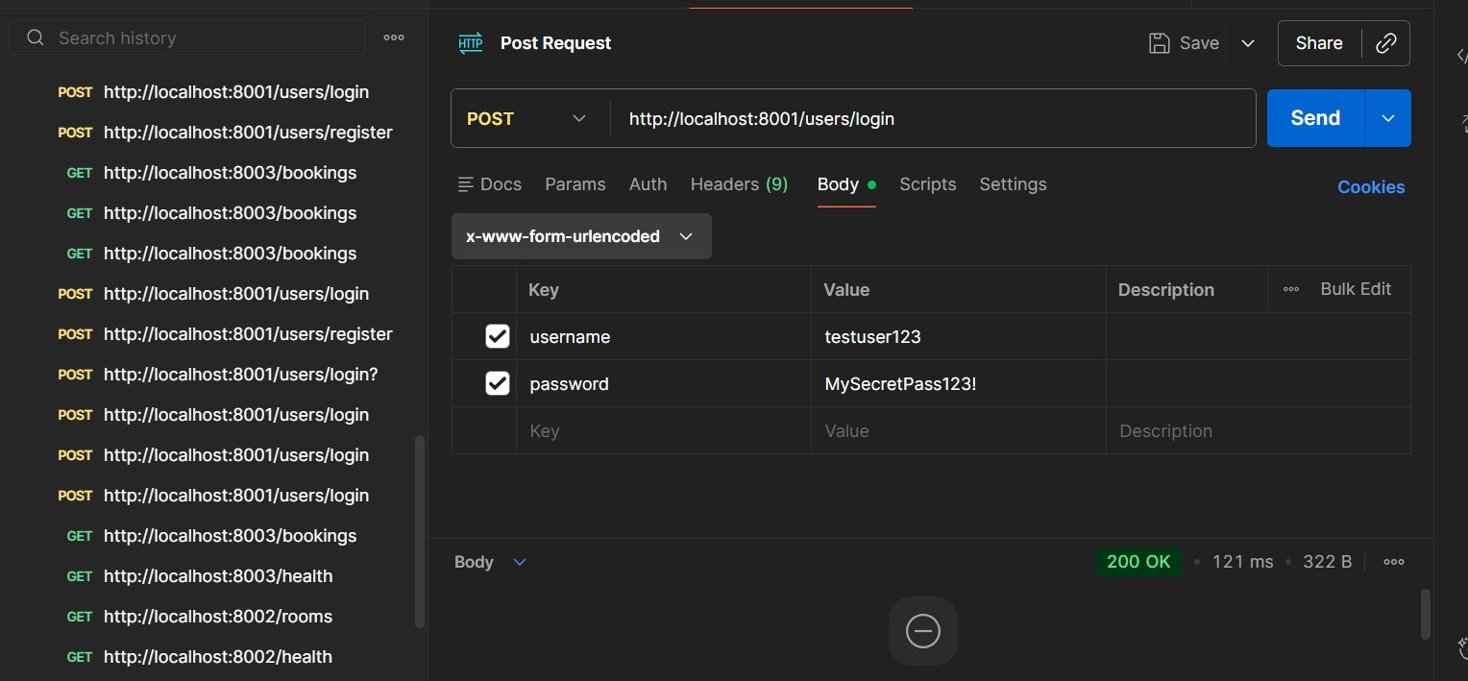

Description: The screenshot shows a successful POST request to /login with a valid username and password. The response includes a JWT token.

Figure 5.4: View Booking History Test in Postman — Laila Monzer

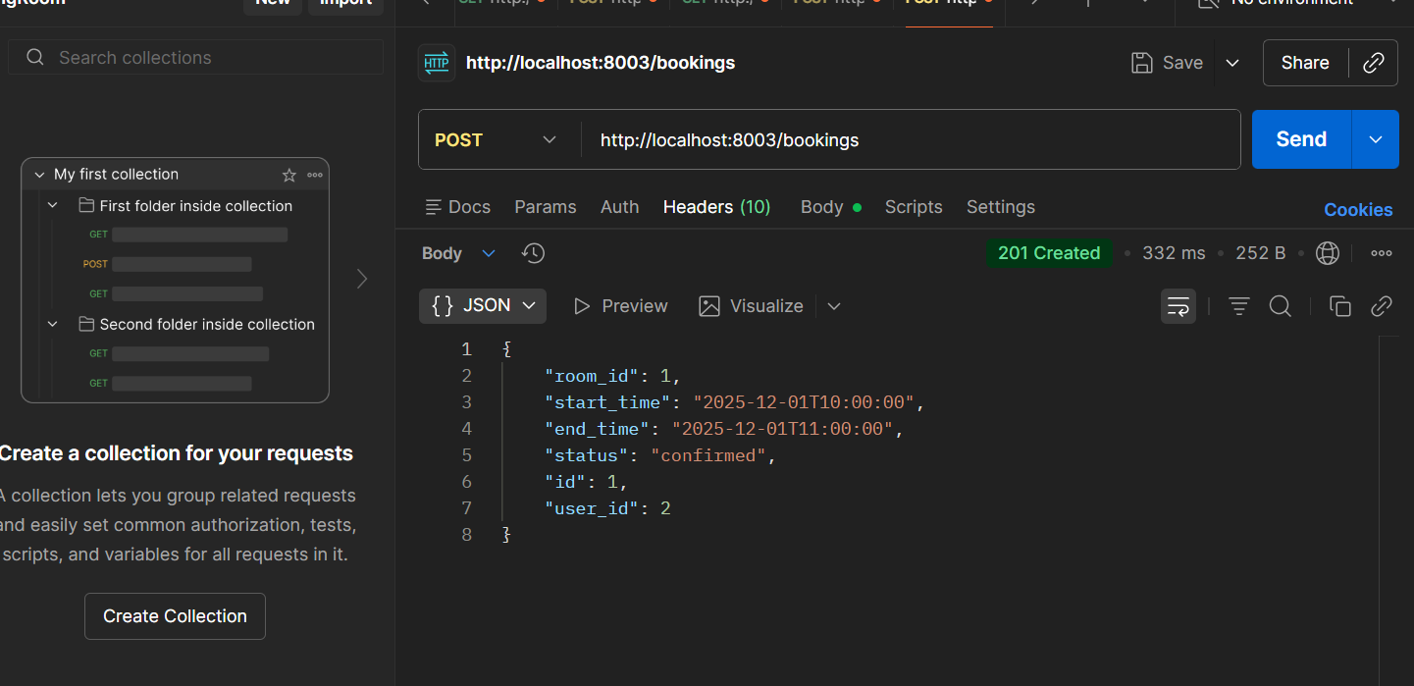

Description: The screenshot shows a successful GET request to “user_id = 2” with a valid JWT token. The response includes a list of bookings for the specified user.

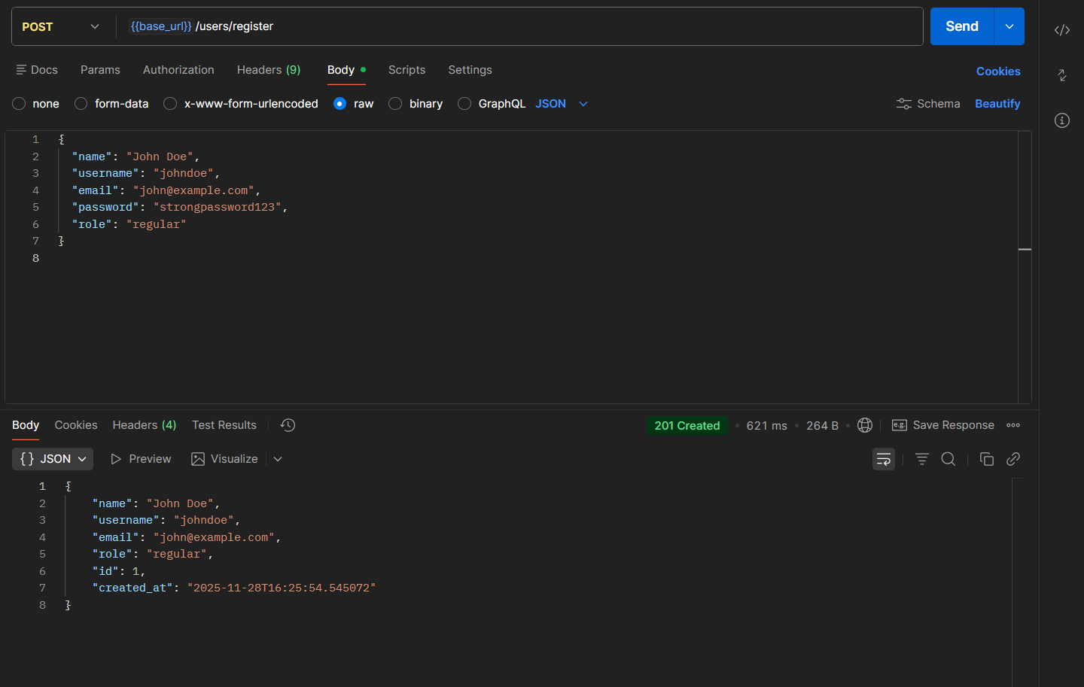

Description : Login returns ana access token which can be used to allow the use of

high authority services

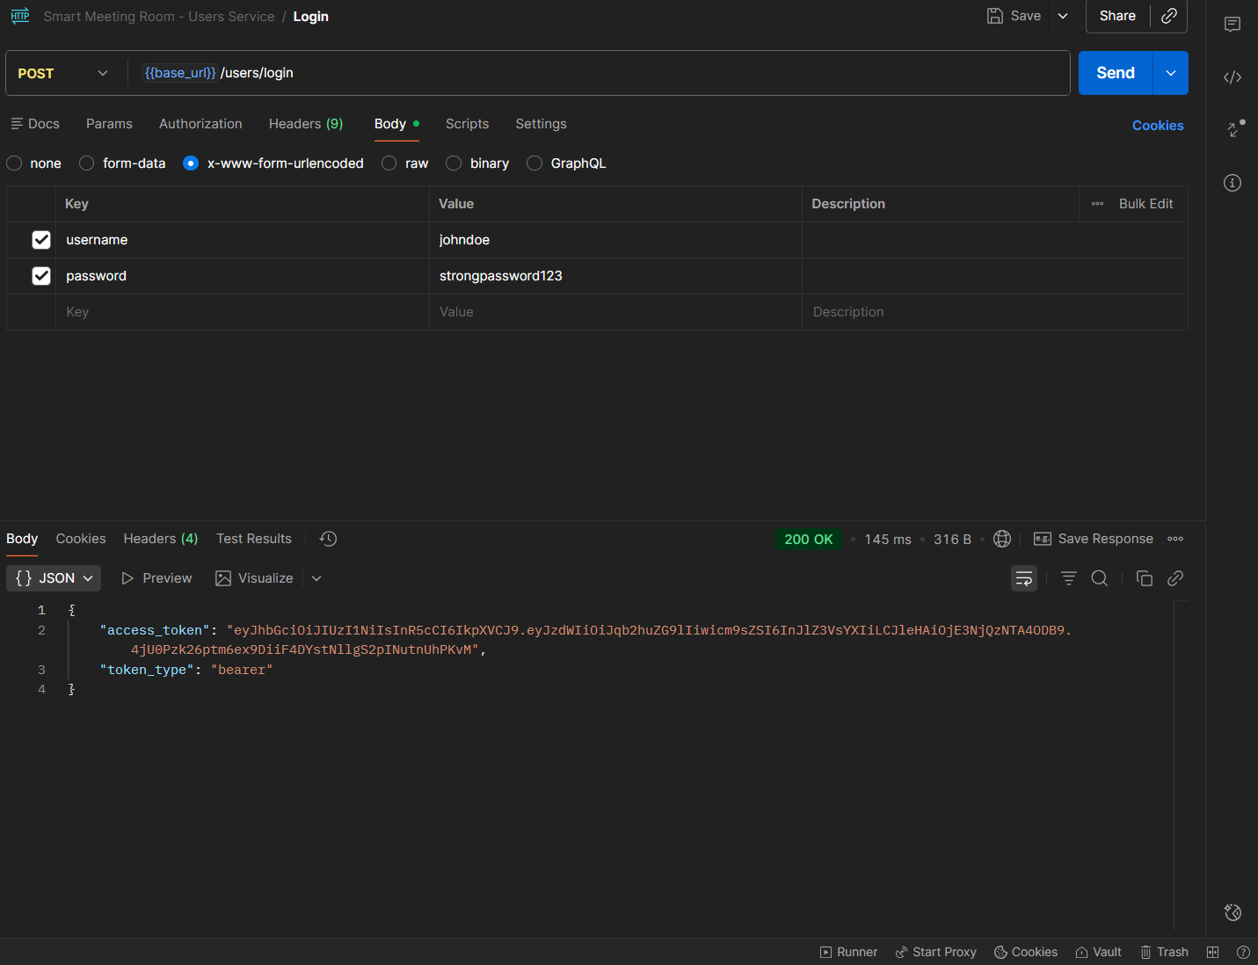

Description: Authorization action , needed to POST user and login

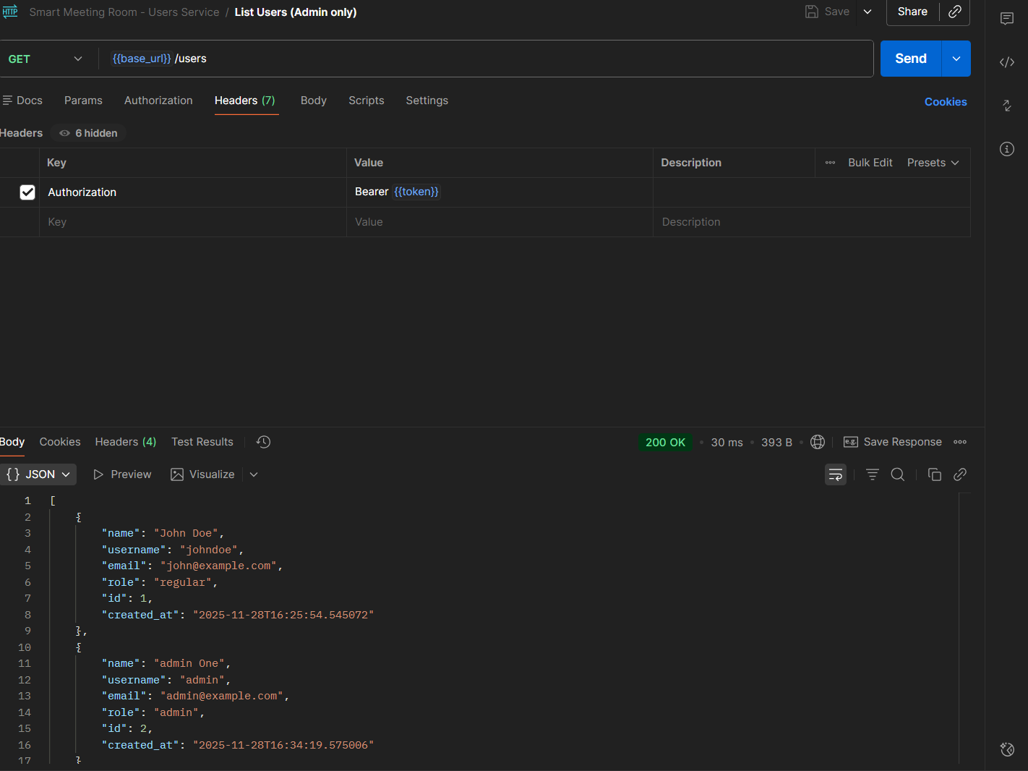

Description : Token is admin gotten after registering an admin and logging in then adding it to environment variables.

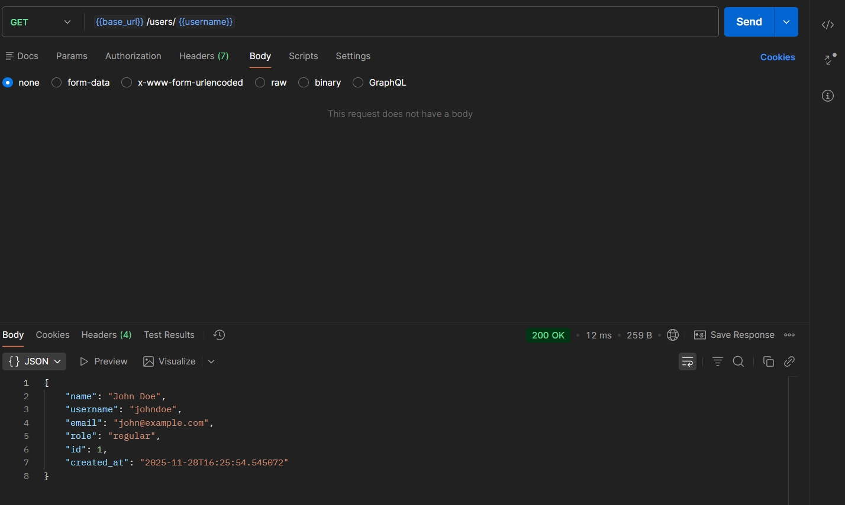

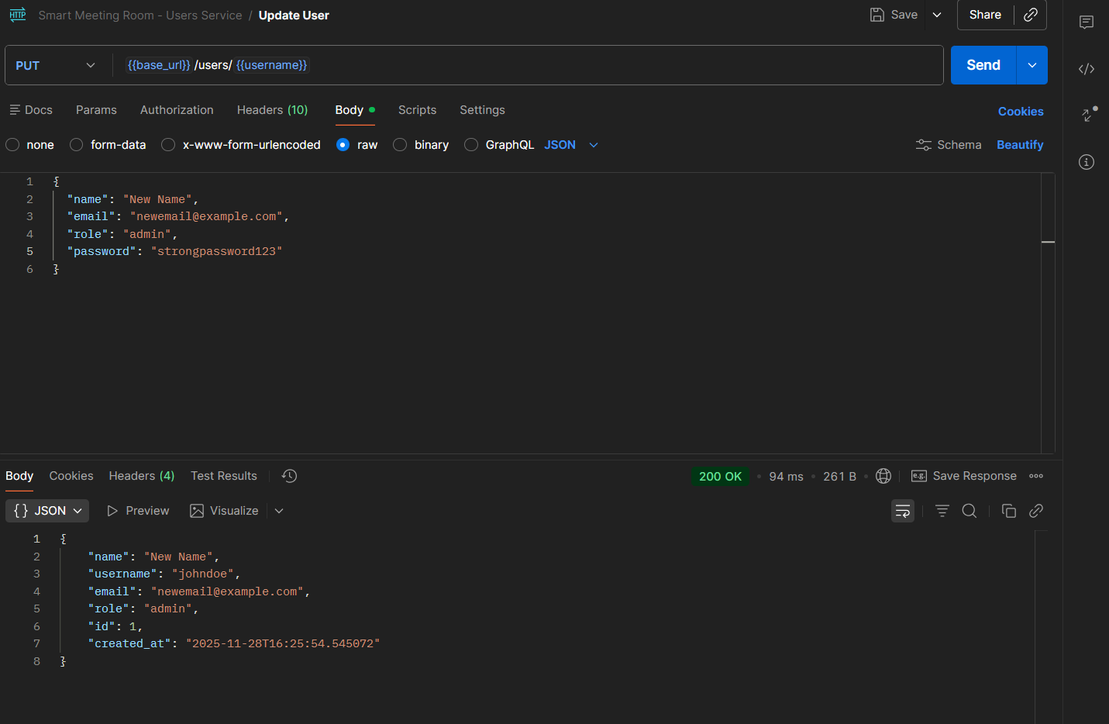

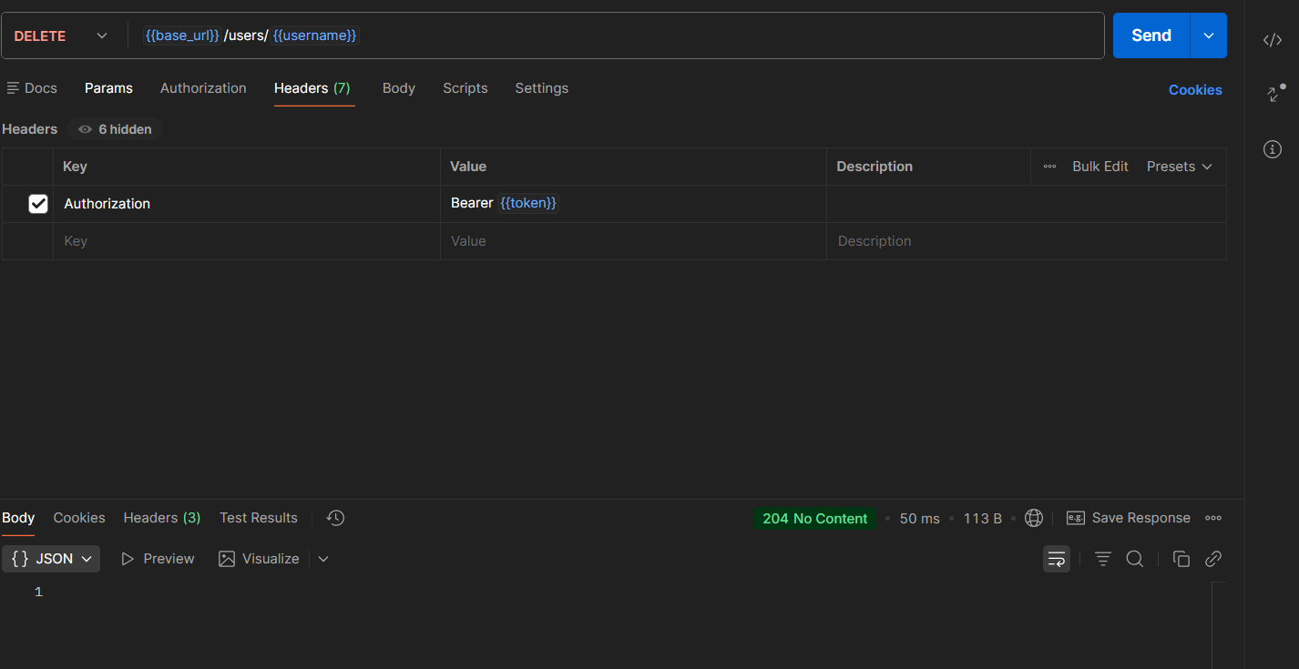

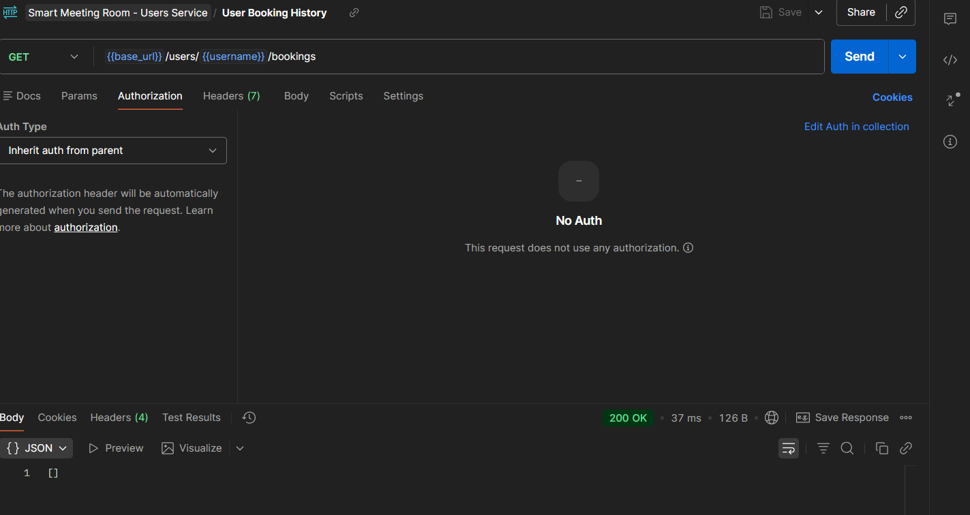

Description: No booking, we have yet to set any.

### 5.2 Service 2: Rooms — Implemented by Ahmad Jazaerli

The Rooms service is responsible for managing meeting room details and availability. It implements the following APIs:

A-Add New Room: Allows Admin or Facility Manager users to add a new meeting room by specifying its name, capacity, equipment, and location.

B-Update Room Details: Allows Admin or Facility Manager users to update the details of an existing room, such as its capacity or equipment.

C-Delete Room: Allows Admin or Facility Manager users to delete a room. This action is irreversible and requires confirmation.

D-Retrieve Available Rooms: Allows users to search for available rooms based on capacity, location, and equipment. The service returns a list of rooms that match the specified criteria.

E-Room Status: Indicates whether a room is available or booked at a specific time. This endpoint is used by the Bookings service to check room availability before creating a new booking.

The service supports multiple user roles (Admin, Facility Manager, Regular User) and enforces RBAC for all operations. For example, only Admin and Facility Manager users can add, update, or delete rooms, while Regular Users can only view room details and availability.

Postman Collection: The screenshots below show the Postman collection for the Rooms service, with all endpoints documented and tested. Each request includes a description and comments for the fields.

Figure 5.5: Postman Collection for Rooms Service — Ahmad Jazaerli

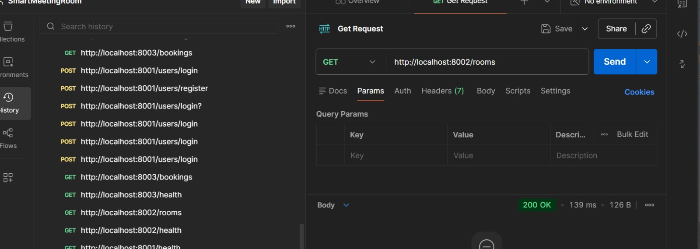Figure 5.6: Add New Room Test in Postman — Ahmad Jazaerli

Description : The screenshot shows a successful POST request to /rooms with a sample payload. The response includes the newly created room’s ID and details.

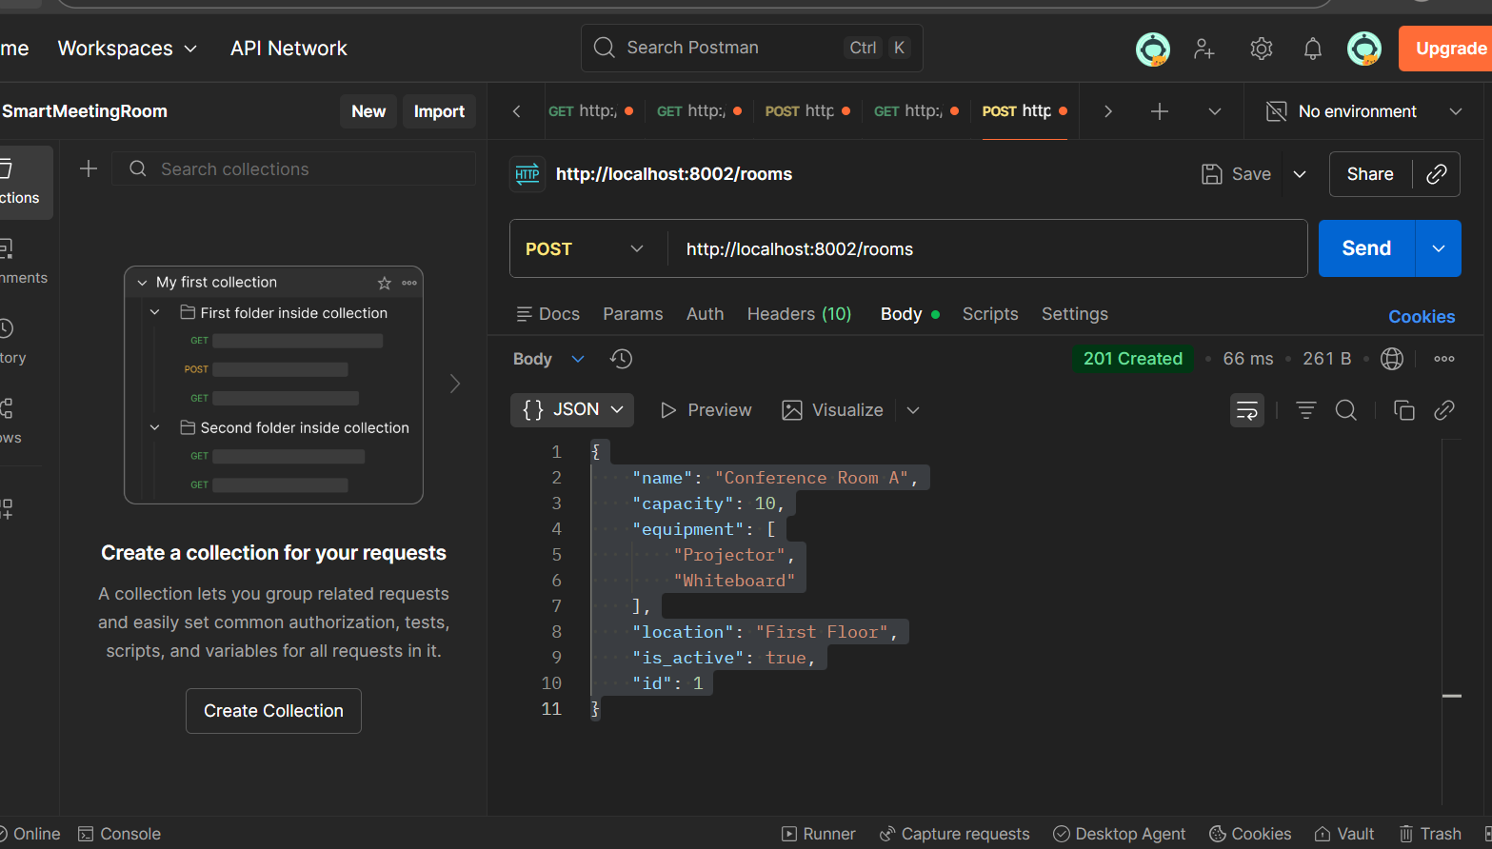Description : This screenshot shows a successful **POST** request to the /rooms endpoint using Postman. The request includes a JSON payload containing room details such as the room name, capacity, equipment list, floor, and active status. The server responds with **HTTP 201 Created**, returning the newly added room along with its generated **ID**, confirming that the room was created correctly.

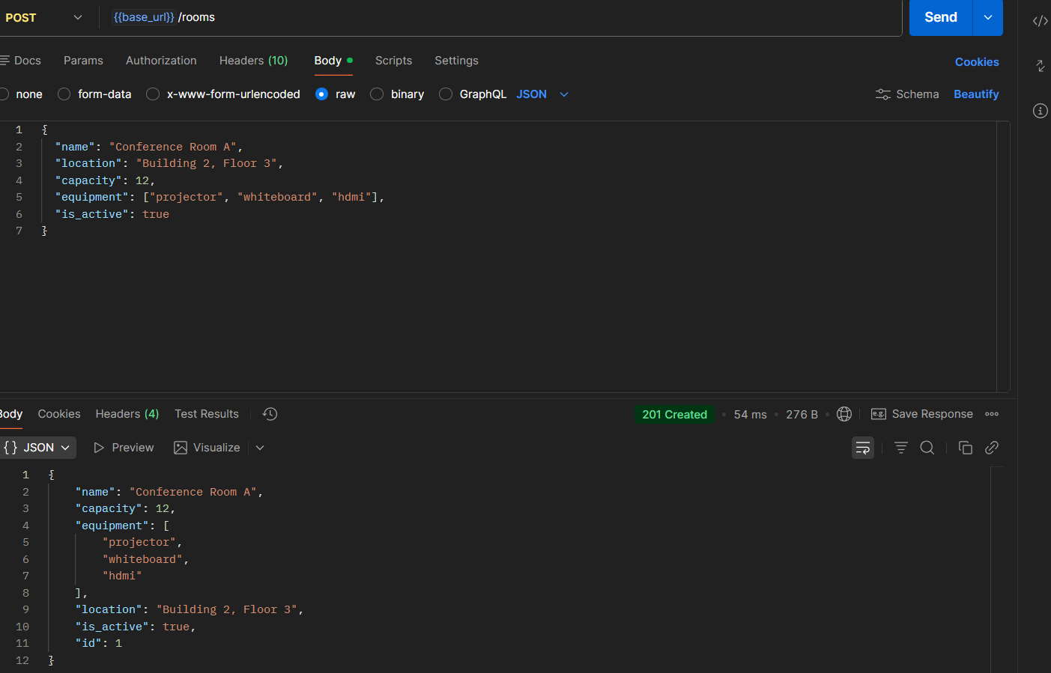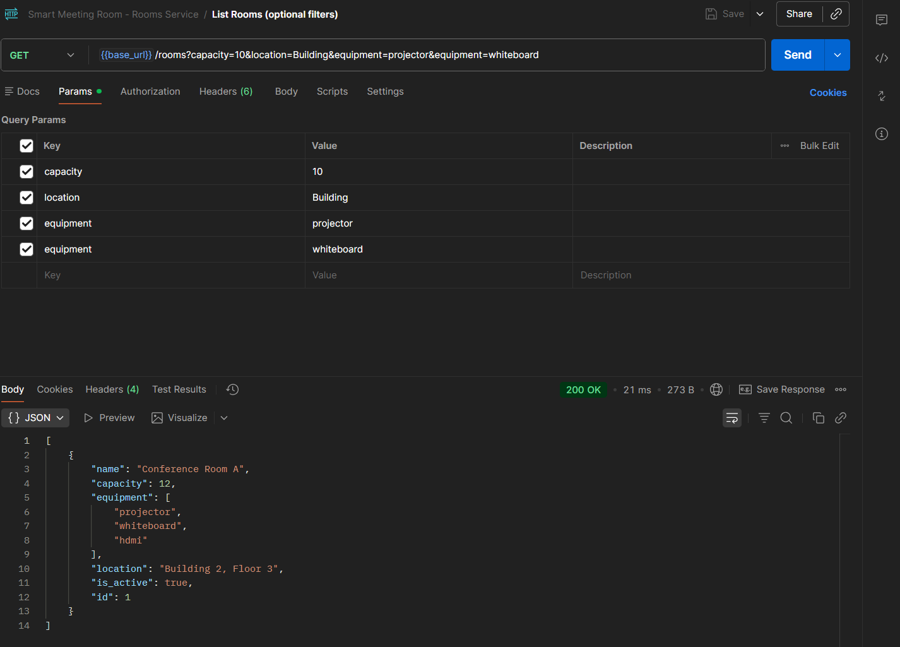Description : Successful GET request to /rooms using capacity, location, and equipment filters. The API returns a 200 OK with the rooms that satisfy the criteria.

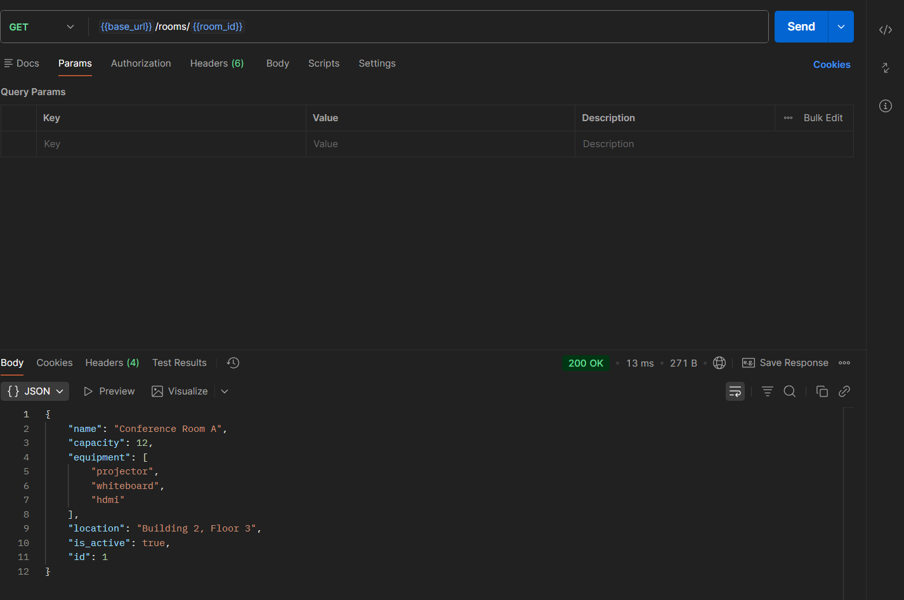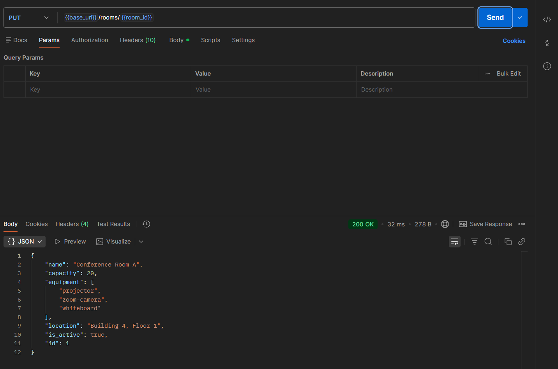

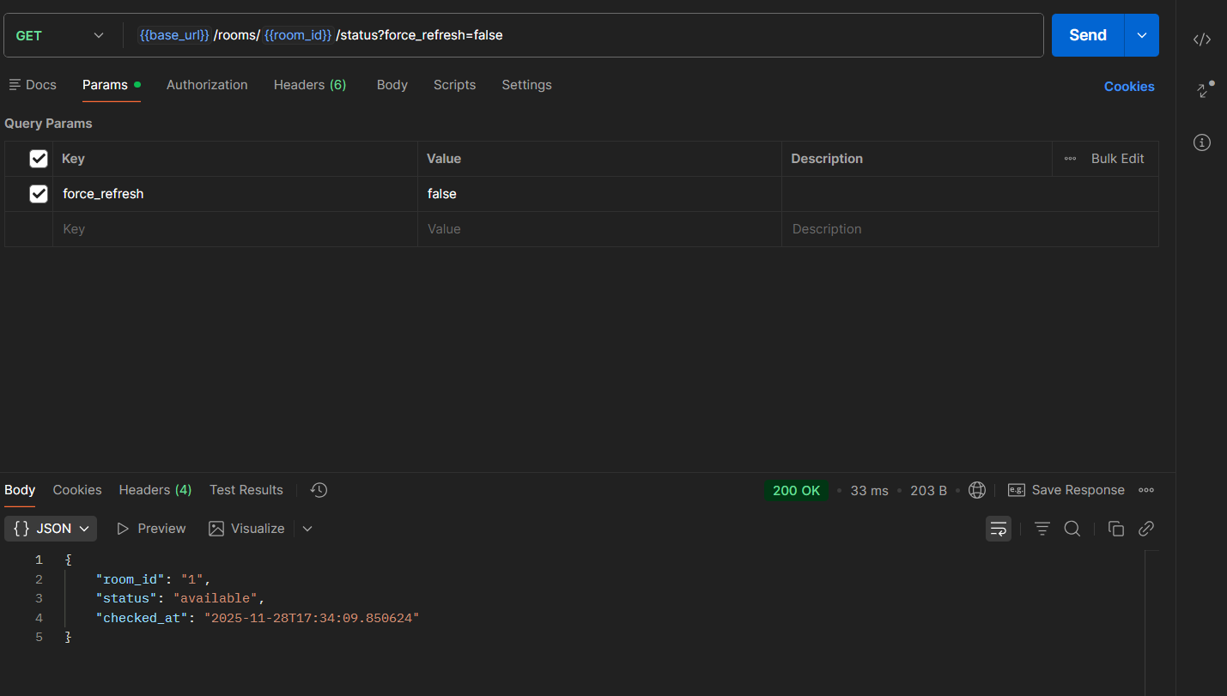Room status before deleting

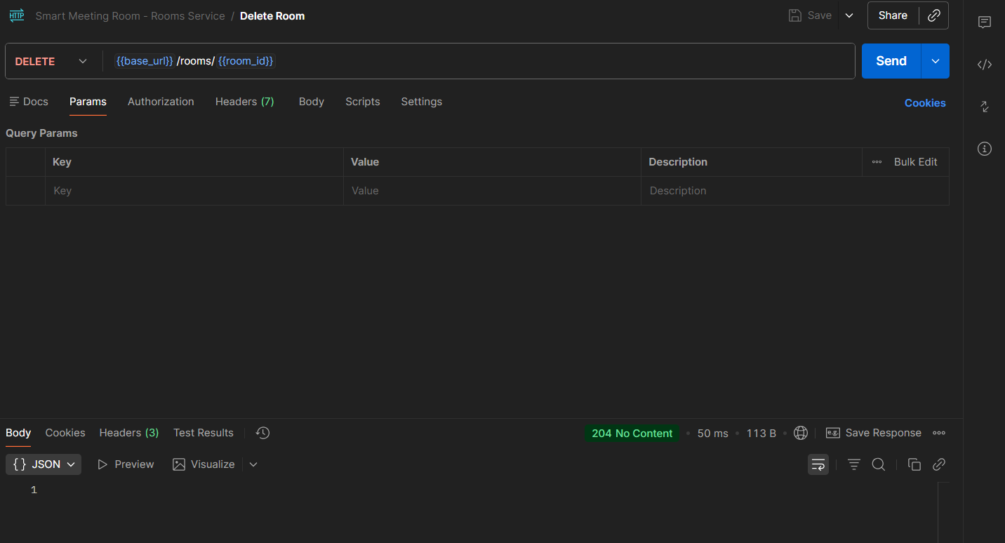

### 5.3 Service 3: Bookings — Implemented by Laila Monzer

The Bookings service is responsible for managing room bookings. It implements the following APIs:

A-View All Bookings: Retrieves a list of all bookings, including details such as the user, room, and time slot. This endpoint is accessible only to Admin users.

B-Make Booking: Allows users to reserve a room by specifying the room ID, start time, end time, and user ID. The service checks room availability before creating the booking.

C-Update Booking: Allows users to modify an existing booking, such as changing the time slot or room. The service checks room availability before updating the booking.

D-Cancel Booking: Allows users to cancel an existing booking. This action is irreversible and requires confirmation.

E-Check Room Availability: Indicates whether a room is available at a specific time. This endpoint is used by the Make Booking and Update Booking endpoints to ensure that bookings are valid.

F-Store Booking History: Stores the booking history for each user. This endpoint is used by the Users service to retrieve a user’s booking history.

The service supports multiple user roles (Admin, Regular User, Facility Manager) and enforces RBAC for all operations. For example, only Admin users can view all bookings, while Regular Users can only create, update, or cancel their own bookings.

Postman Collection: The screenshots below shows the Postman collection for the Bookings service, with all endpoints documented and tested. Each request includes a description and comments for the fields.

Figure 5.9: Postman Collection for Bookings Service — Laila Monzer

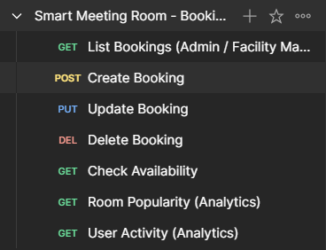

Description:The screenshot shows a successful POST request to /bookings with a sample payload. The response includes the newly created booking’s ID and details.

Figure 5.10: Make Booking Test in Postman — Laila Monzer

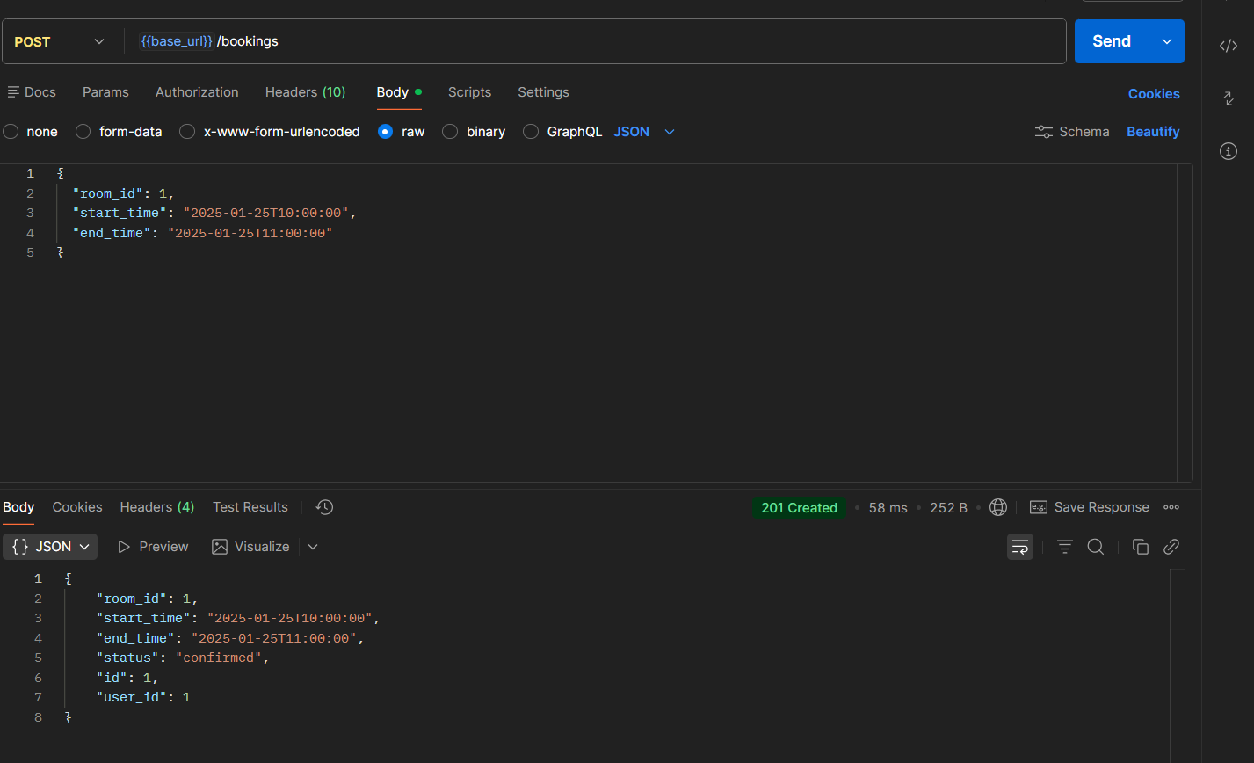

.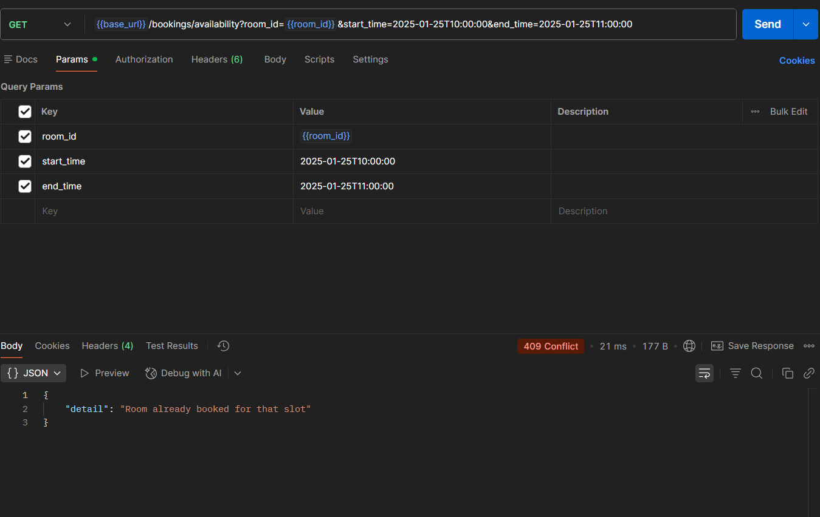Description : Room is already booked so our system acts correctly and returns that the room is already booked so this acts as a room checking evidence

Figure 5.12: View Booking History Test in Postman — Laila Monzer

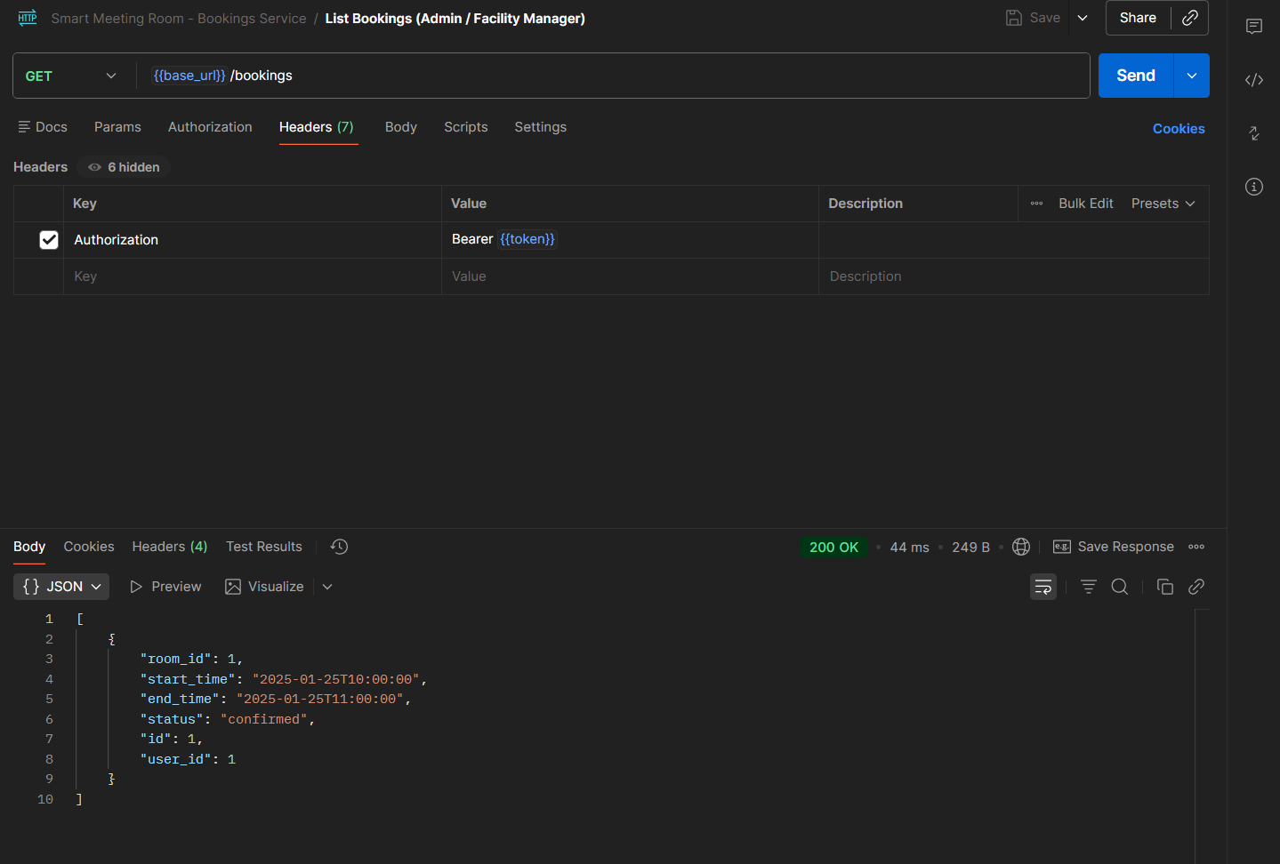

This implementation ensures that bookings are managed accurately, and that users can easily reserve, modify, or cancel rooms.

Room popularity: 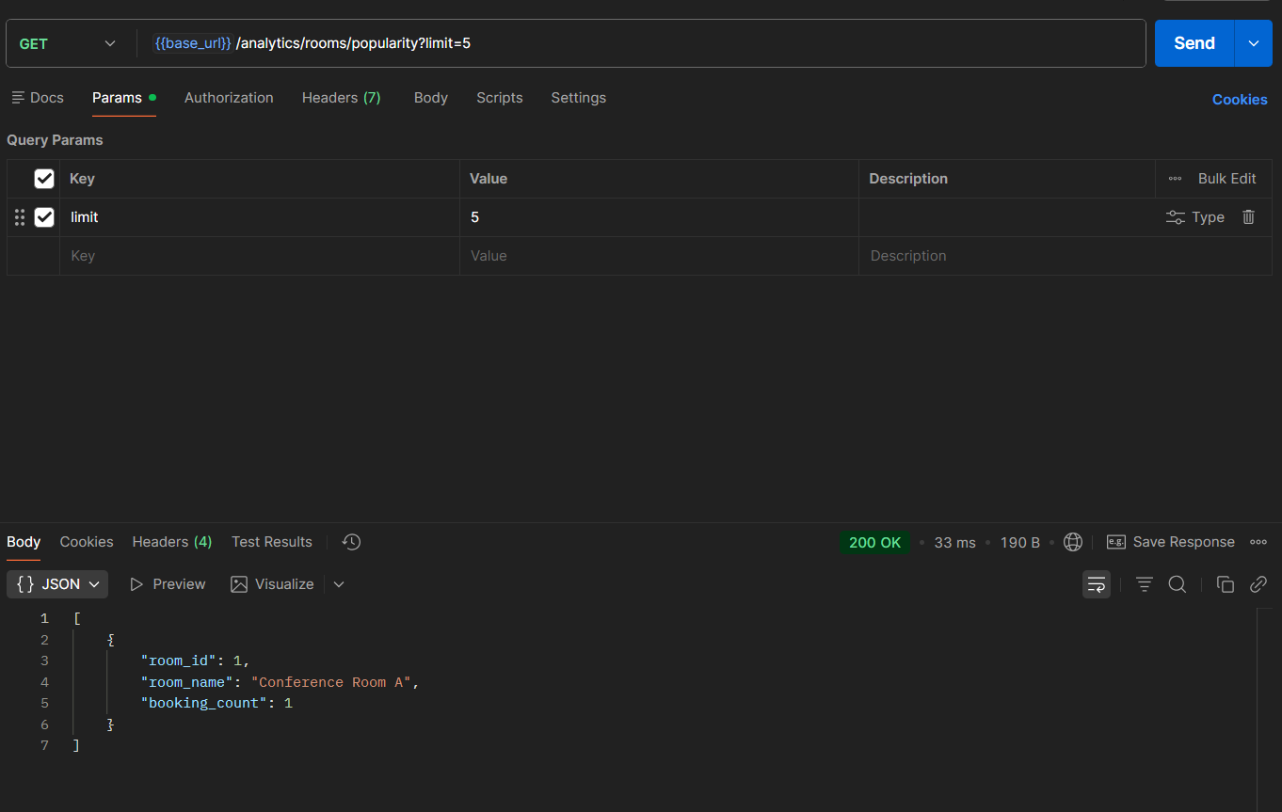

User Activity:

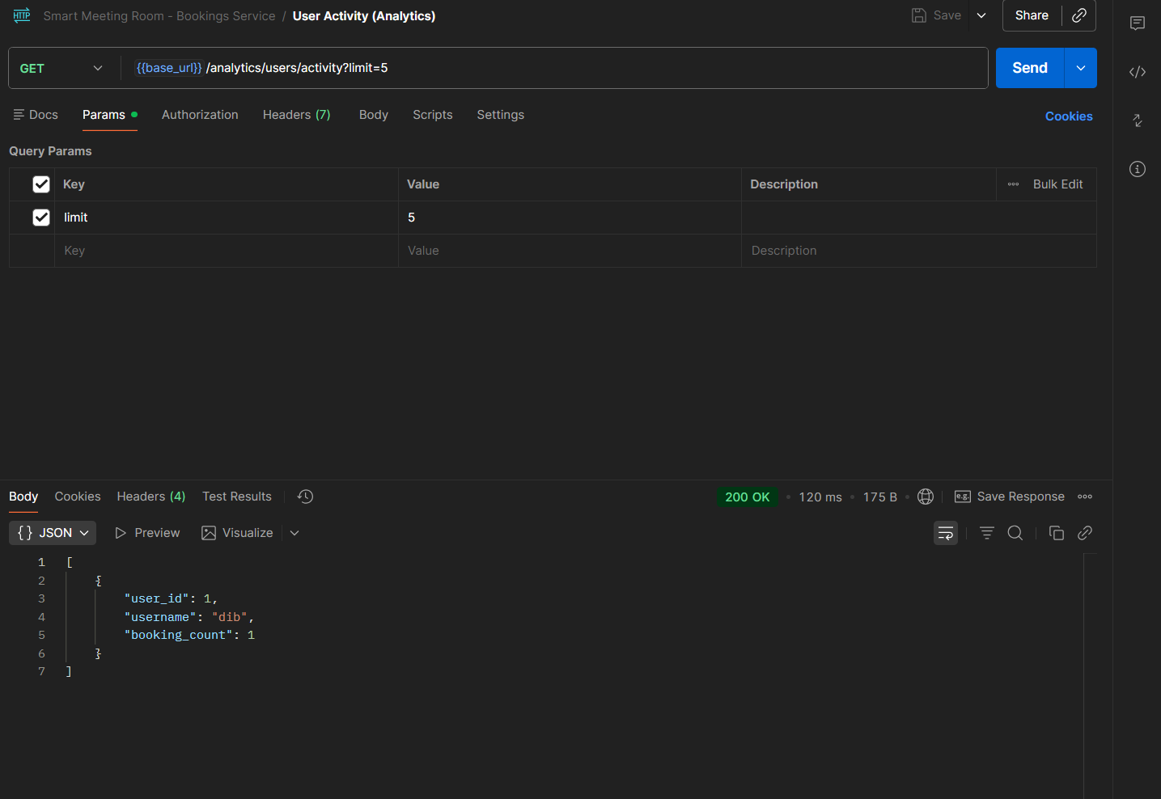

Updating a booking:

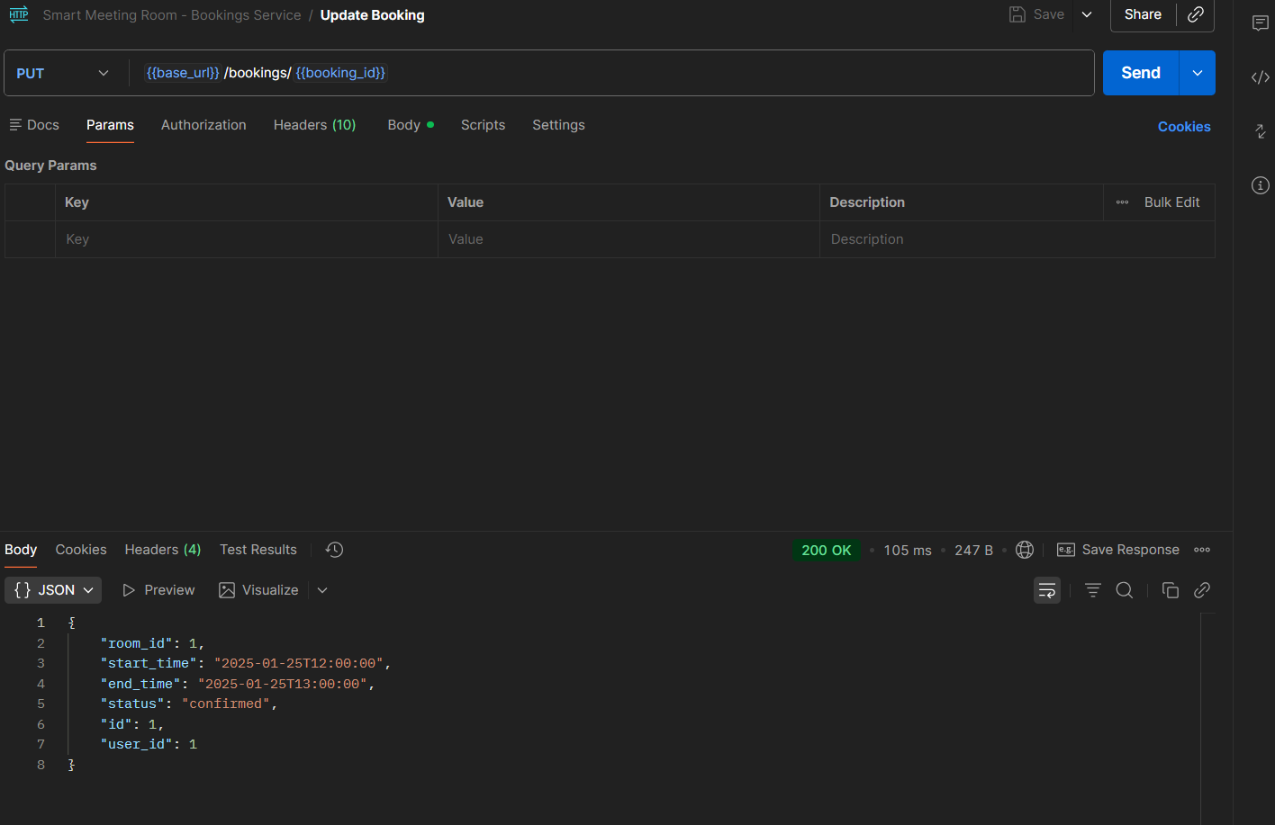

Deletion is also successful:  
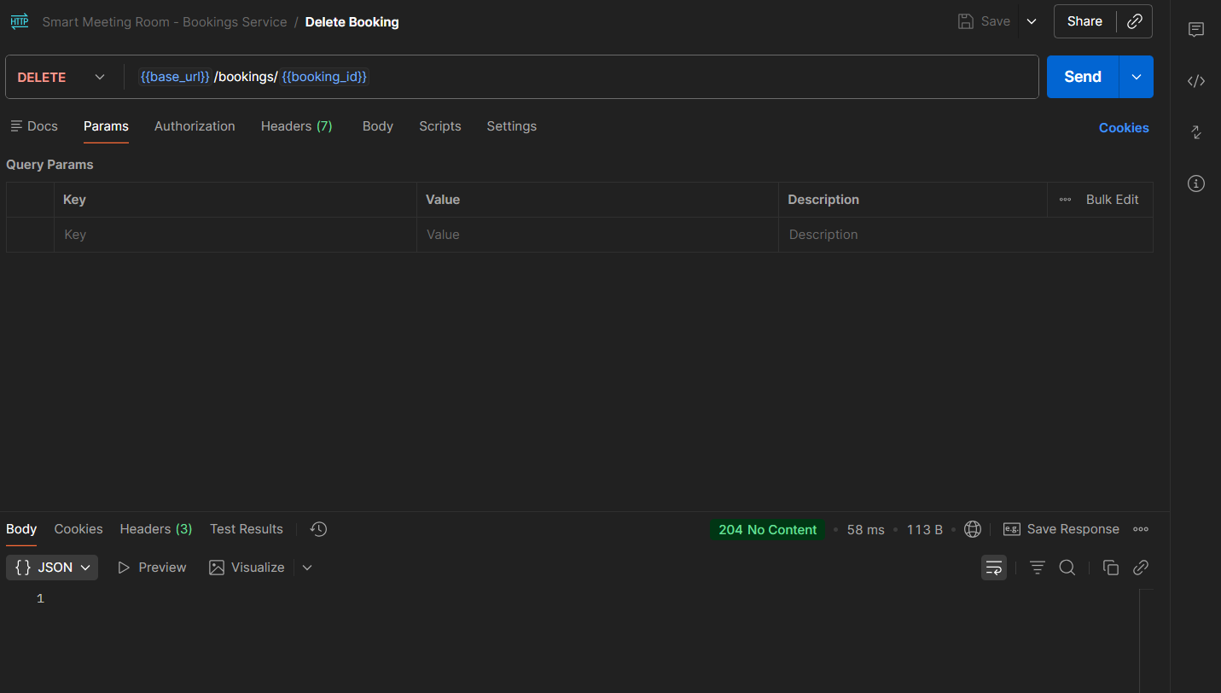

### 5.4 Service 4: Reviews — Implemented by Ahmad Jazaerli

### 

The Reviews service is responsible for managing room reviews. It implements the following APIs:

A-Submit Review: Allows users to submit a review for a meeting room by specifying the room ID, rating, and comment. The service validates the input and stores the review in the database.

B-Update Review: Allows users to update their own review by specifying the review ID, new rating, and new comment.

C-Delete Review: Allows users to delete their own review. This action is irreversible and requires confirmation.

D-Retrieve Reviews for a Room: Retrieves a list of reviews for a specific room. This endpoint is accessible to all users.

E-Moderate Reviews: Allows Moderator or Admin users to flag, hide, or delete inappropriate reviews. The service also includes a reporting mechanism for users to flag reviews they find inappropriate.

The service supports multiple user roles (Regular User, Moderator, Auditor) and enforces RBAC for all operations. For example, only Regular Users can submit, update, or delete their own reviews, while Moderator and Admin users can moderate reviews.

Postman Collection: The screenshots below shows the Postman collection for the Reviews service, with all endpoints documented and tested. Each request includes a description and comments for the fields.

Figure 5.13: Postman Collection for Reviews Service — Ahmad Jazaerli

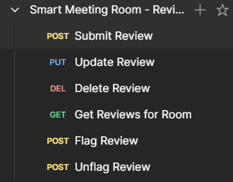

Figure 5.14: Submit Review Test in Postman — Ahmad Jazaerli

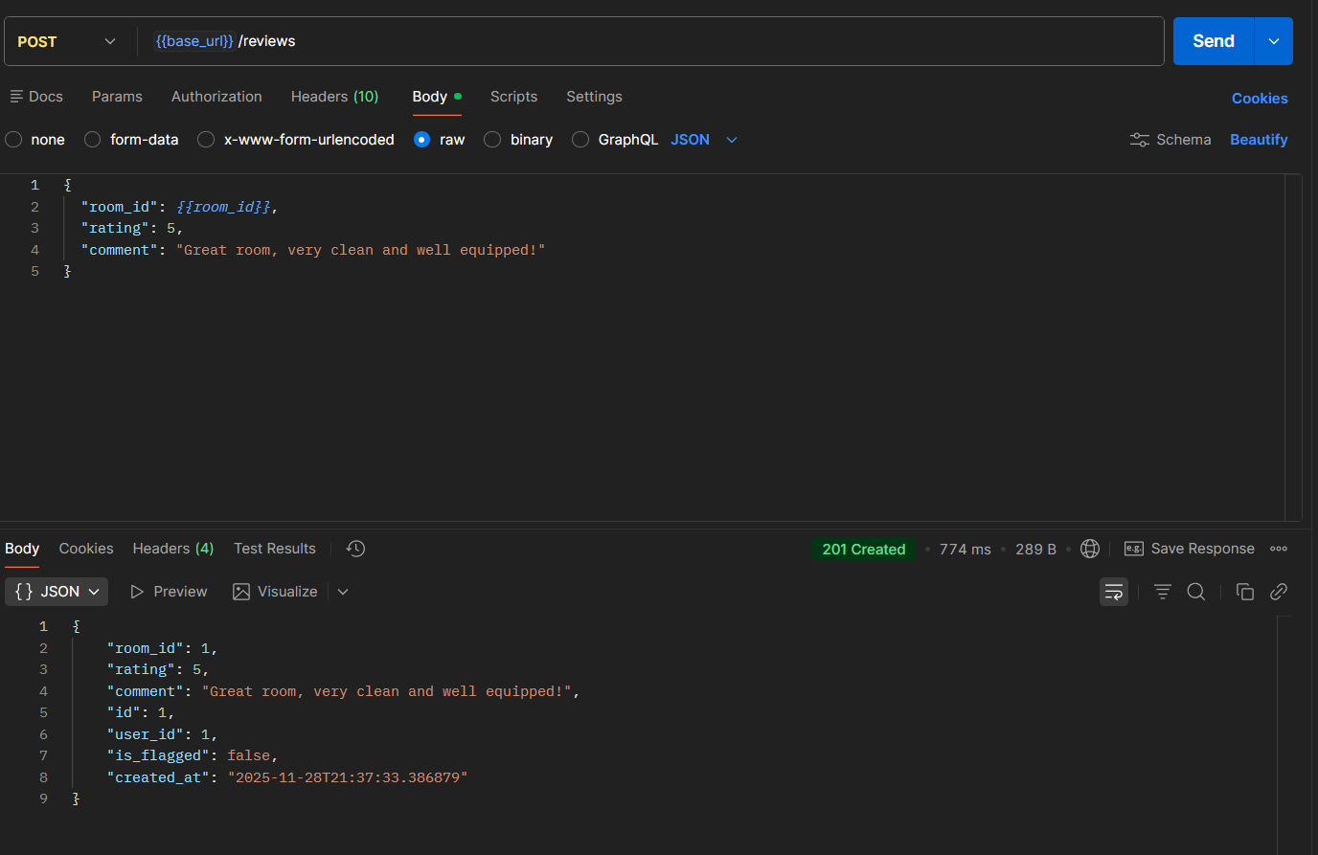Description : The screenshot shows a successful POST request to /reviews with a sample payload. The response includes the newly created review’s ID and details.

When updating a review the token was now invalid since its time limit had ran out:

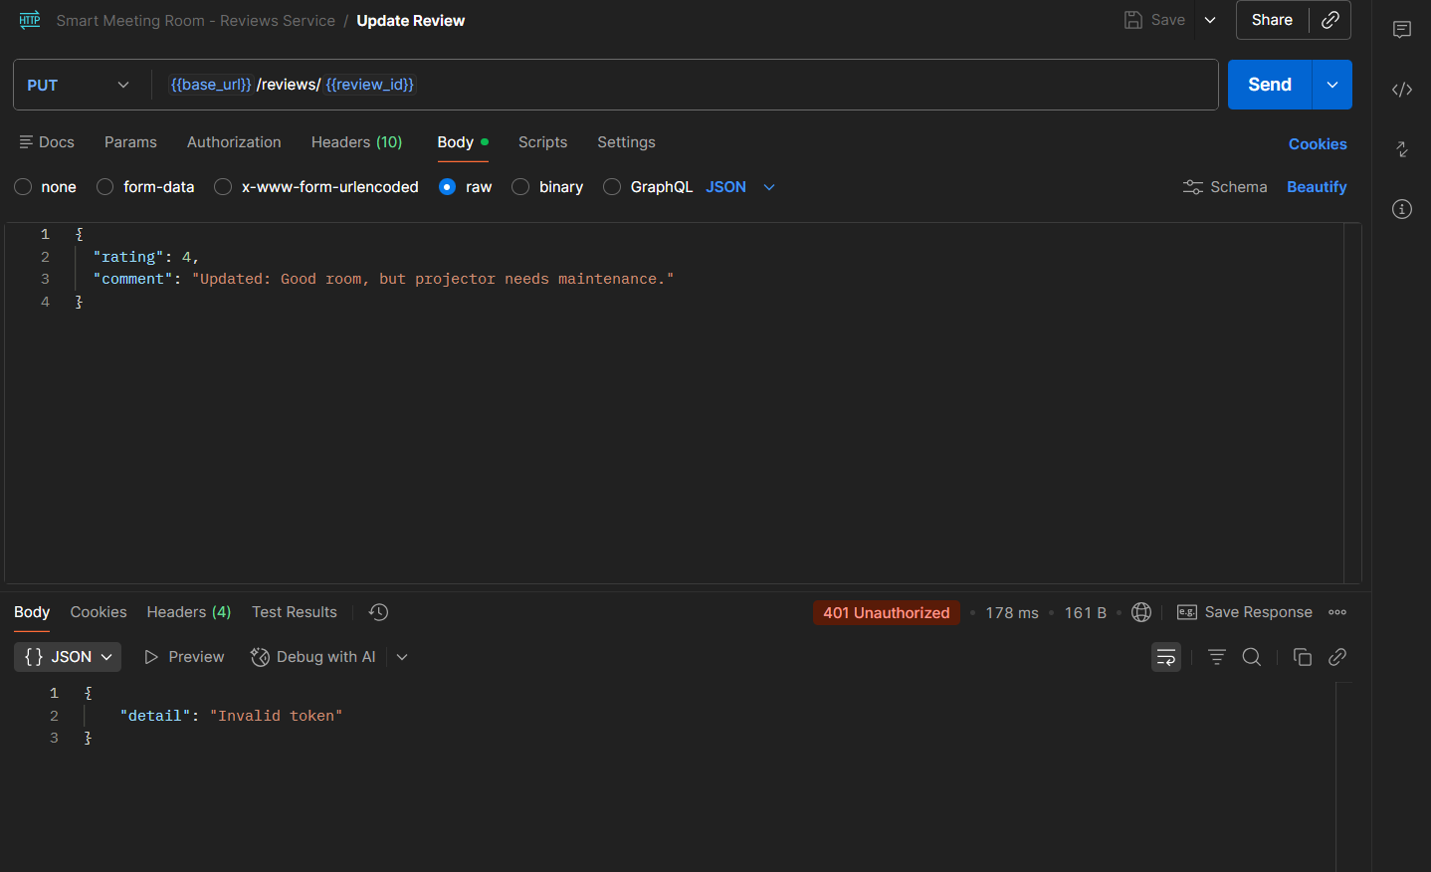After logging in again and updating the token updating the review works as follows: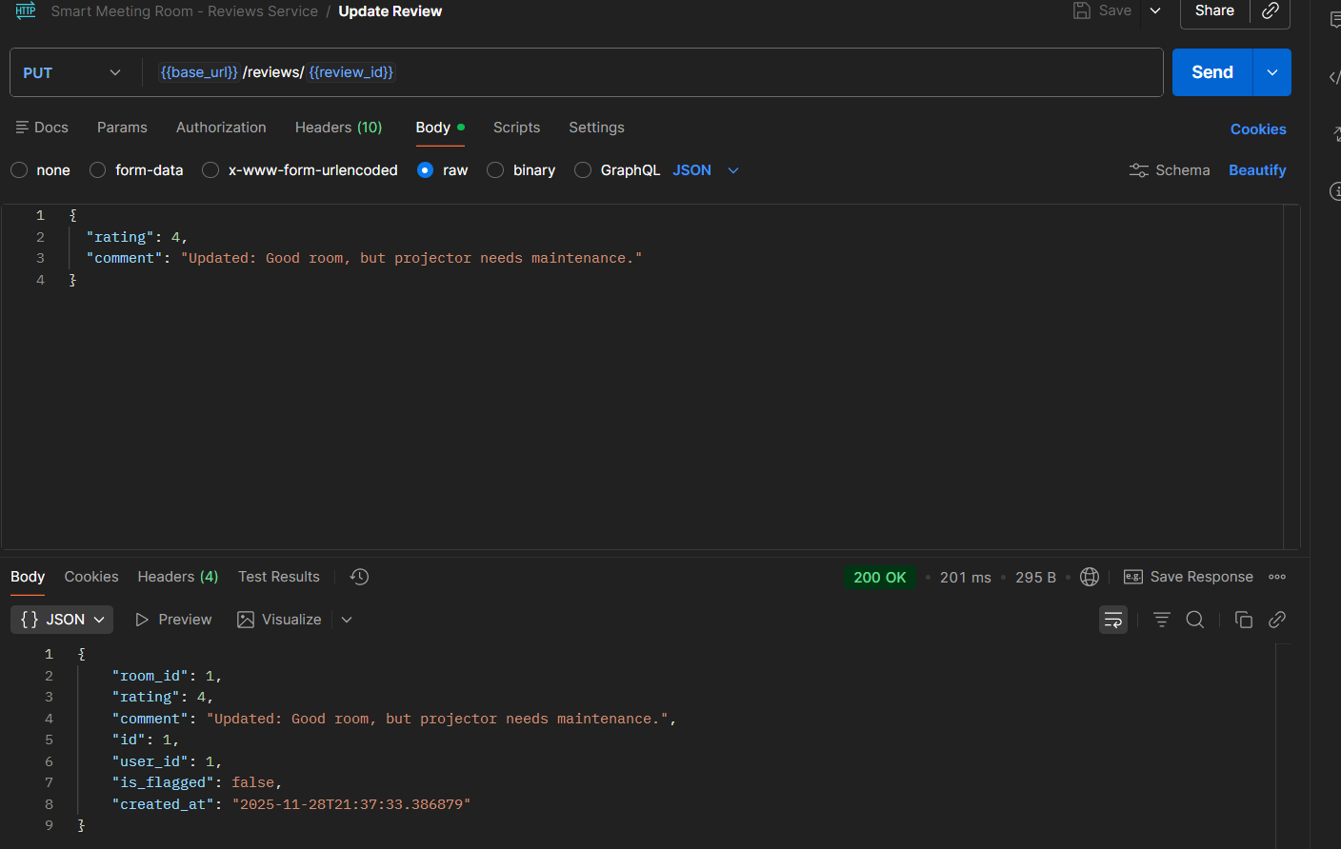

Figure 5.15: Retrieve Reviews for a Room Test in Postman — Ahmad Jazaerli

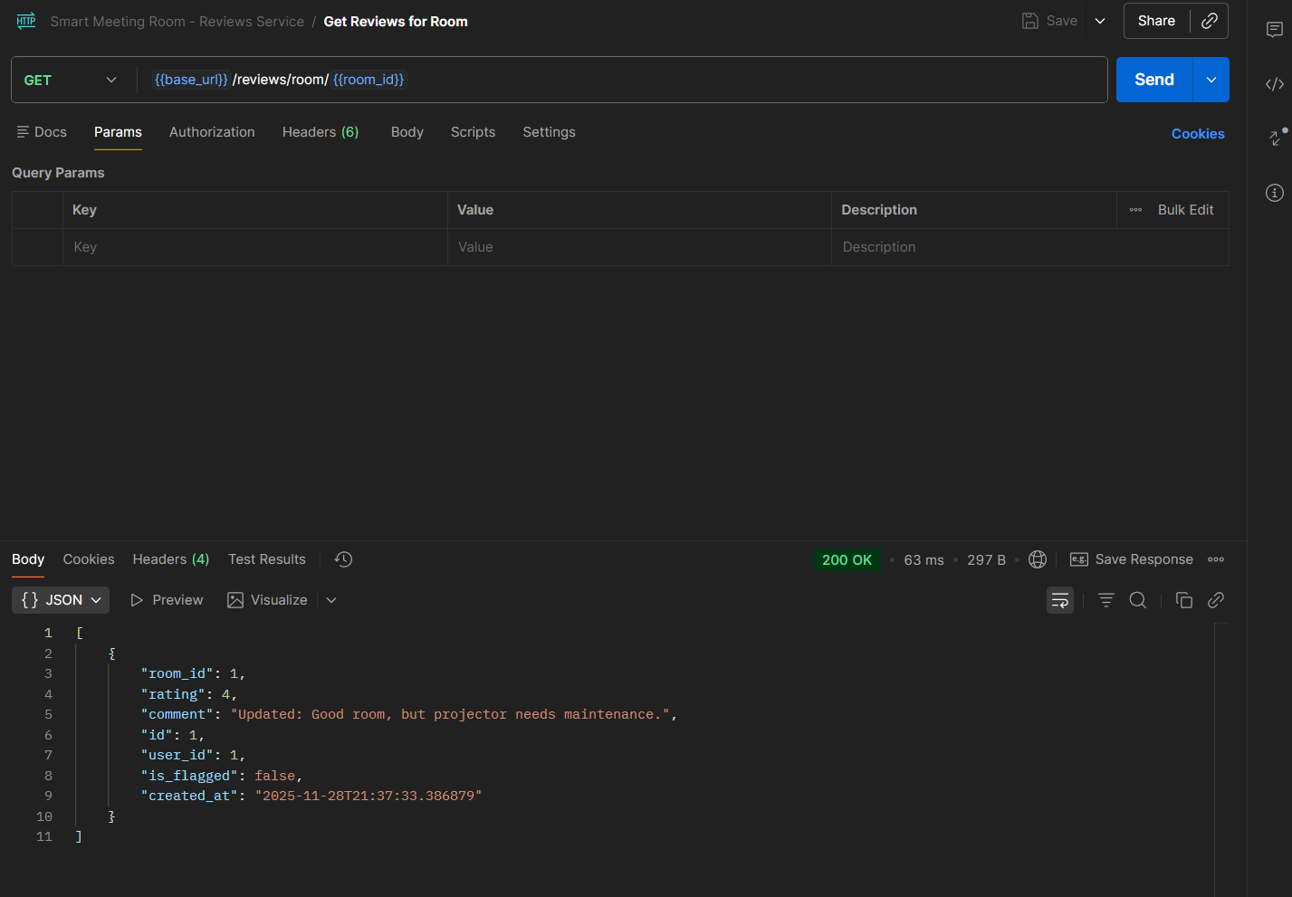Description The screenshot shows a successful GET request to /rooms/{id}/reviews with a valid JWT token. The response includes a list of reviews for the specified room.

Figure 5.16: Moderate Review Test in Postman — Ahmad Jazaerli

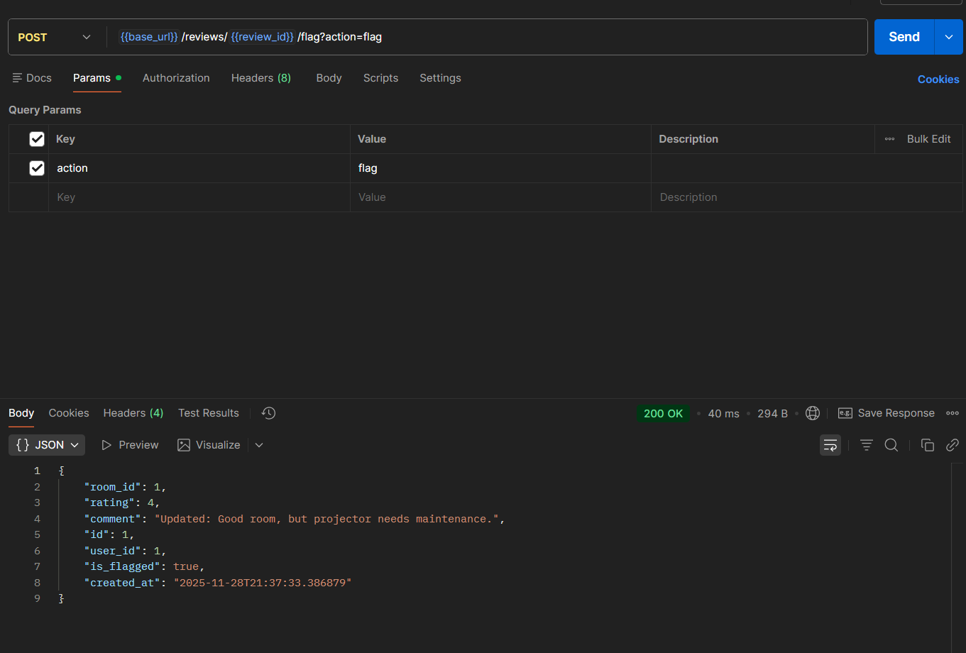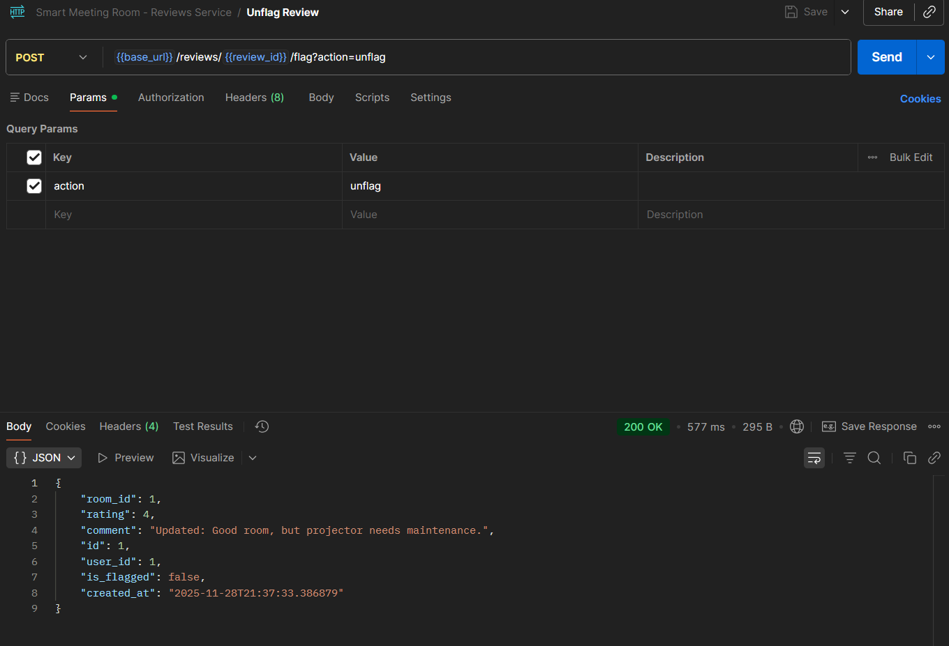

Now deleting the a review also functions: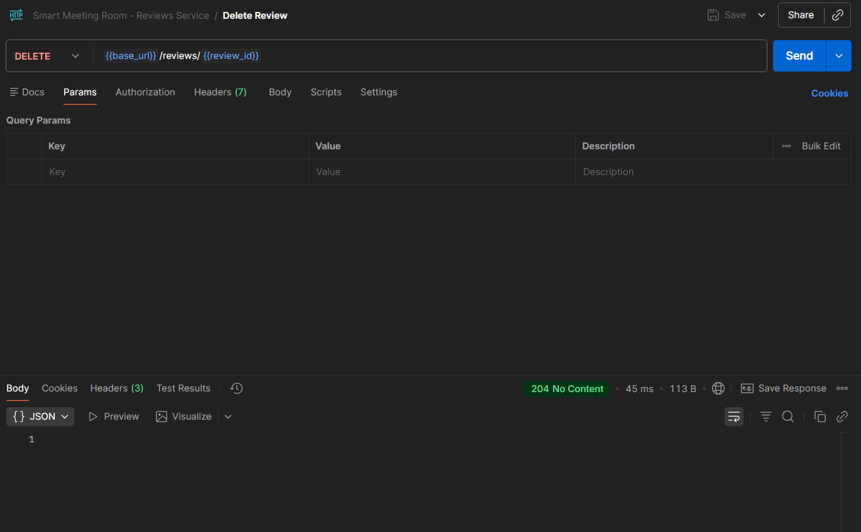

This implementation ensures that reviews are managed fairly and that inappropriate content can be quickly identified and removed.

## Database Design — Implemented by Both (Laila: Schema, Ahmad: Relationships)

The database schema consists of four main tables: users, rooms, bookings, and reviews. Each table has a primary key and foreign keys to establish relationships between entities.

The users table stores user information, including their name, username, password, email, and role. The rooms table stores room details, including the room name, capacity, equipment, location, and availability status. The bookings table stores booking information, including the user ID, room ID, start time, end time, and status. The reviews table stores review information, including the user ID, room ID, rating, comment, and moderation status.

The relationships between the tables are as follows:

A user can have many bookings. A room can have many bookings. A user can submit many reviews. A room can have many reviews.

Database Schema Diagram: The screenshot below shows the database schema diagram, illustrating the tables and their relationships.

Figure 6.1: Database Schema Diagram — Laila Monzer (Schema), Ahmad Jazaerli (Relationships)

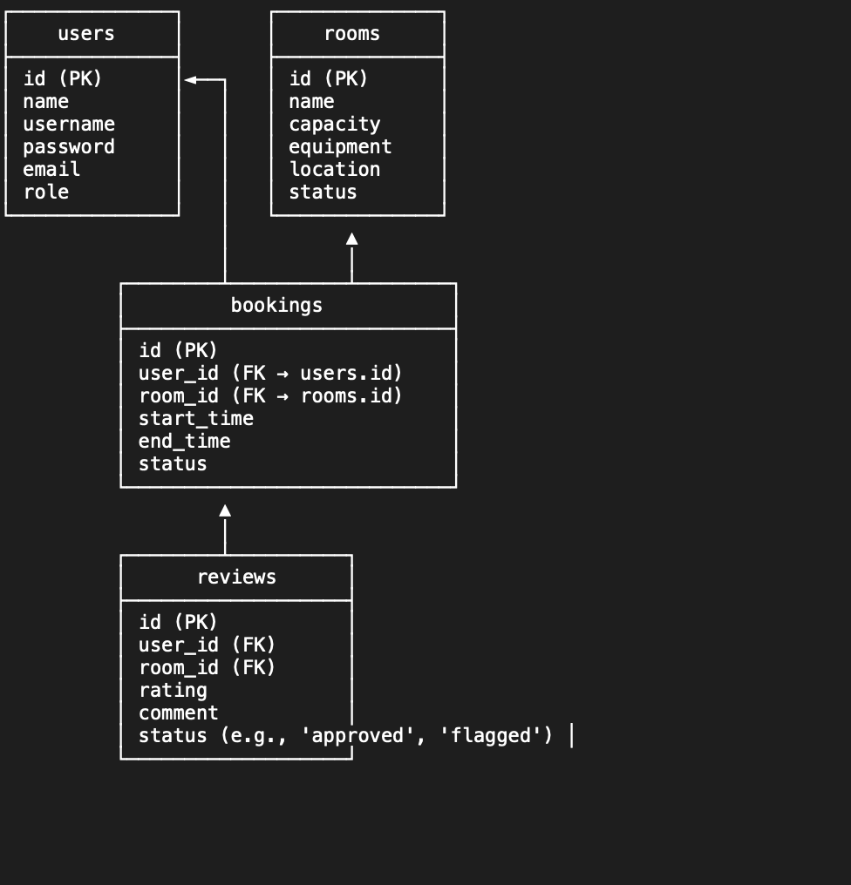

Database Indexes: The screenshot below shows the output of a script that lists all database indexes. The indexes are created on frequently queried fields, such as user_id, room_id, and booking_date, to optimize query performance. Figure 6.2: Database Indexes Output — Laila Monzer

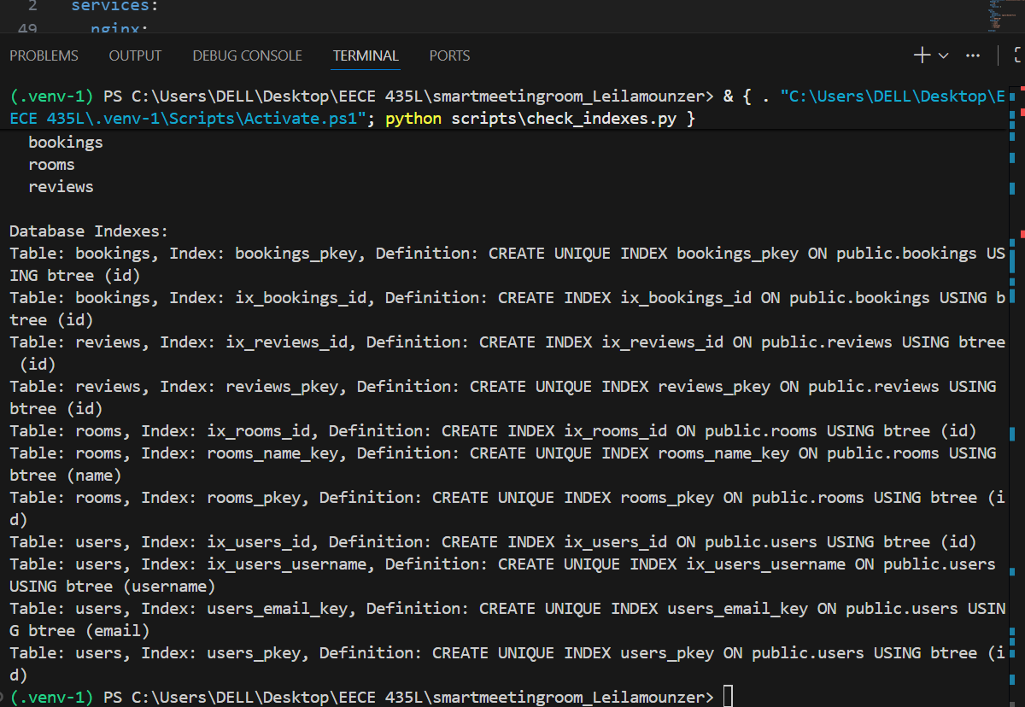

This design ensures that the database is normalized and optimized for performance, with appropriate indexes to speed up common queries.

## Error Handling and Validation — Implemented by Laila Monzer

Error handling and validation are critical components of any robust system. In our project, we implemented a global error handler that catches exceptions and returns standardized error messages to the client. This ensures that errors are handled consistently across all services and that clients receive clear, actionable feedback.

We also implemented input validation for all API endpoints to prevent common security issues, such as SQL injection and cross-site scripting (XSS). For example, we validate that user inputs for reviews are sanitized before being stored in the database. We use regular expressions and built-in validation libraries to ensure that inputs meet the required format and length constraints.

Evidence of Implementation:

Global Error Handler: The screenshot below shows the code for the global error handler, which catches exceptions and returns a standardized error message.

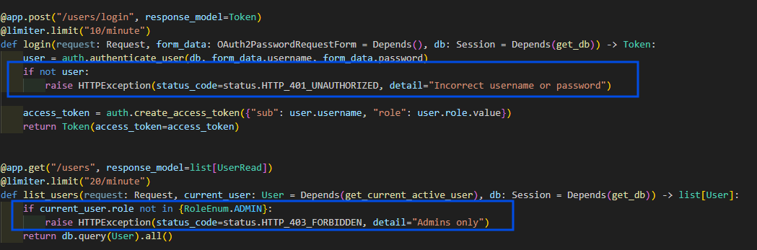

Unauthorized personal trying to access action not permitted to them. Error handled,

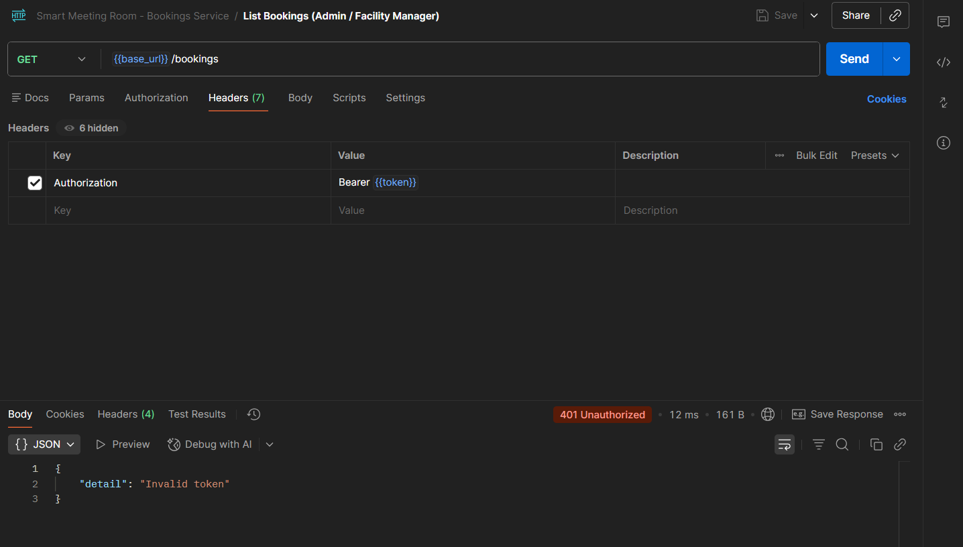

Input Validation: The screenshot below shows the code for input validation in the Reviews service, which sanitizes user inputs before storing them in the database.

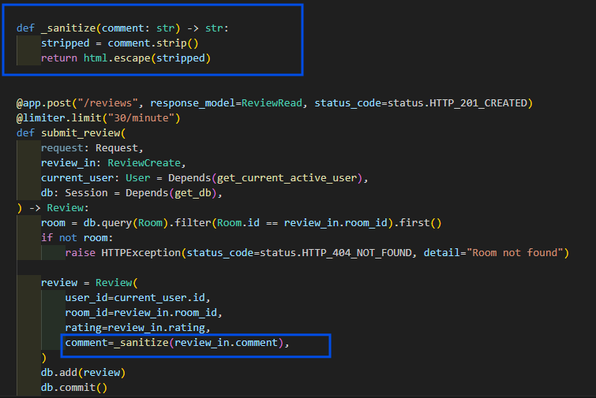

Validation Test: The screenshot below shows a test case that verifies input validation. The test sends an invalid input to the API and expects a 400 Bad Request response.

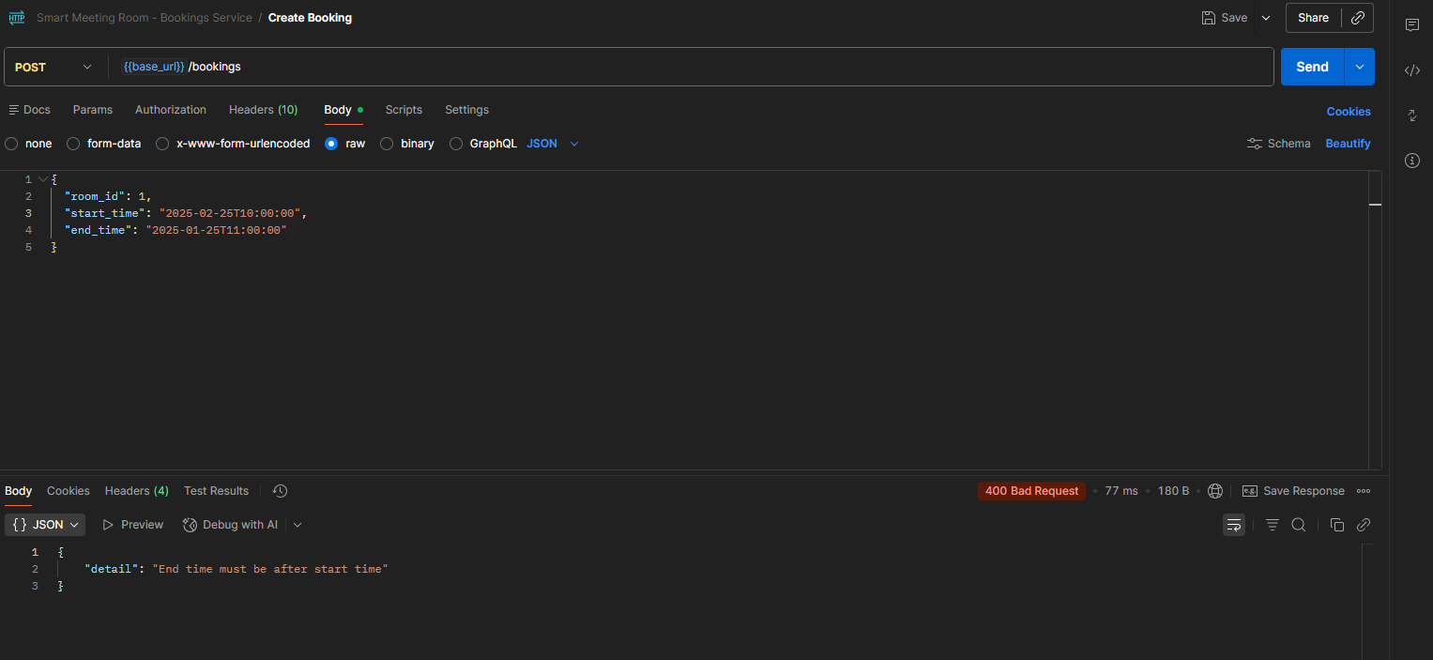

This implementation ensures that the system is secure and that errors are handled gracefully, providing a better user experience.

### Testing — Implemented by Ahmad Jazaerli

Testing is an essential part of the development process, ensuring that the system functions as expected and that bugs are caught early. In our project, we implemented unit tests using Pytest for all services. These tests cover all API endpoints and verify that they return the correct responses for various inputs.

We also implemented integration tests to verify that the services communicate correctly with each other and with the database. These tests simulate real-world scenarios, such as creating a booking and then retrieving the booking history for a user.

Integration Test: The screenshot below shows the code for an integration test that verifies the interaction between the Users and Bookings services. The test creates a user, makes a booking, and then retrieves the user’s booking history.

Figure 8.2: Integration Test Code — Ahmad Jazaerli

User Integration Tests:  
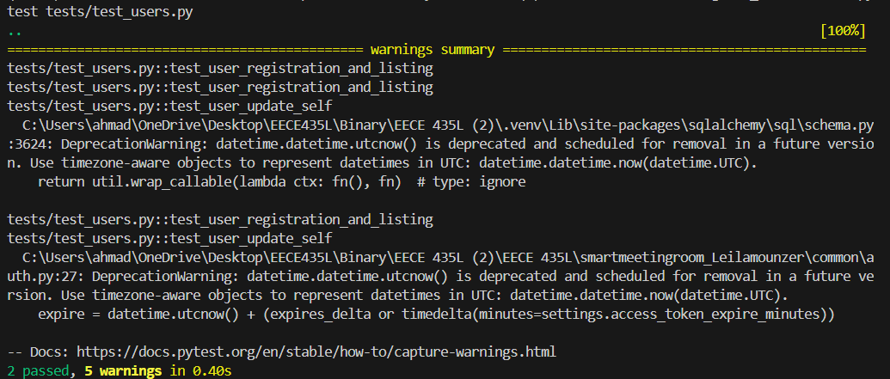

Rooms Integration Tests:  
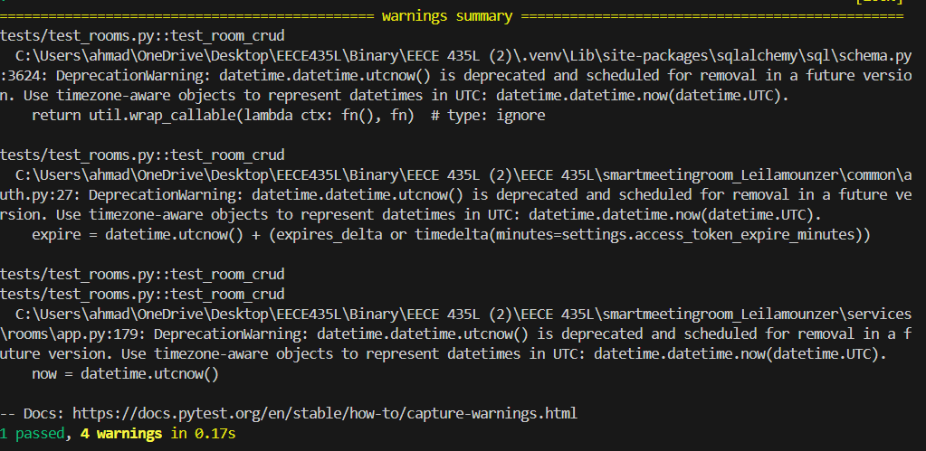Bookings Integration Tests

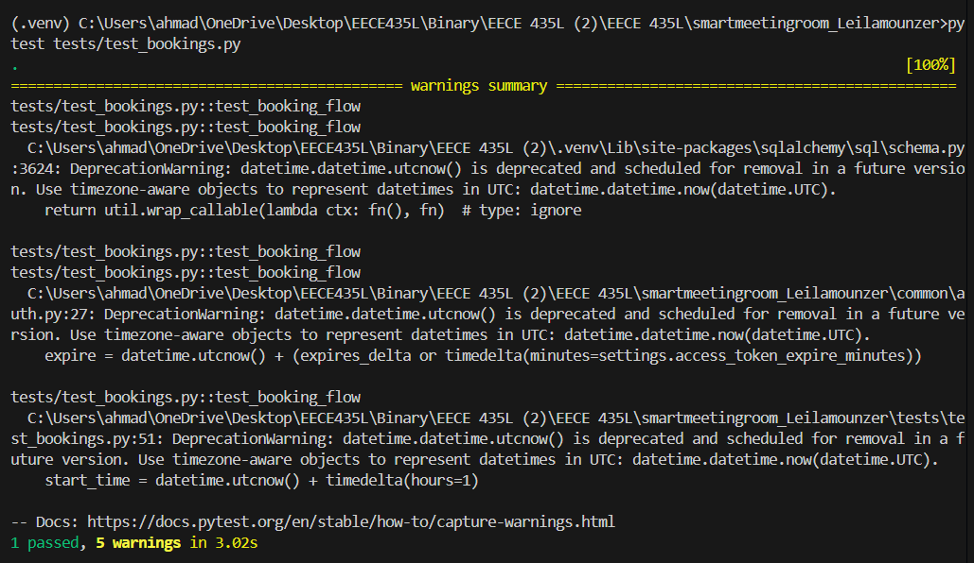Reviews Integration Tests:  
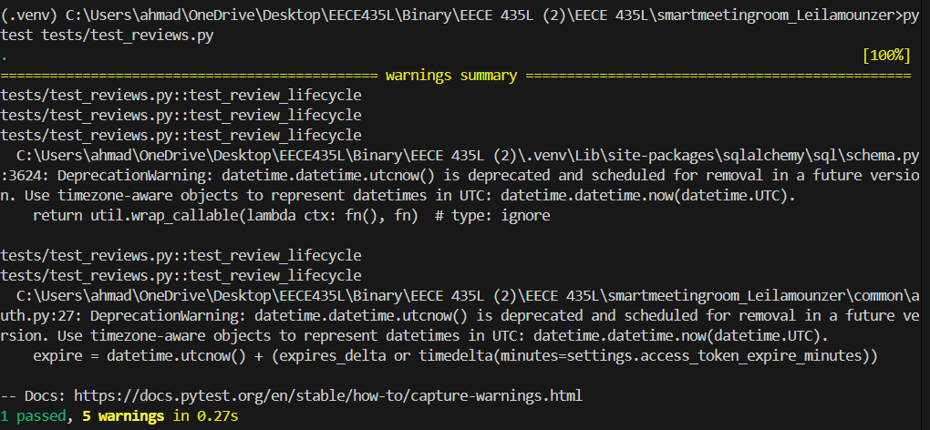

Unite Tests:

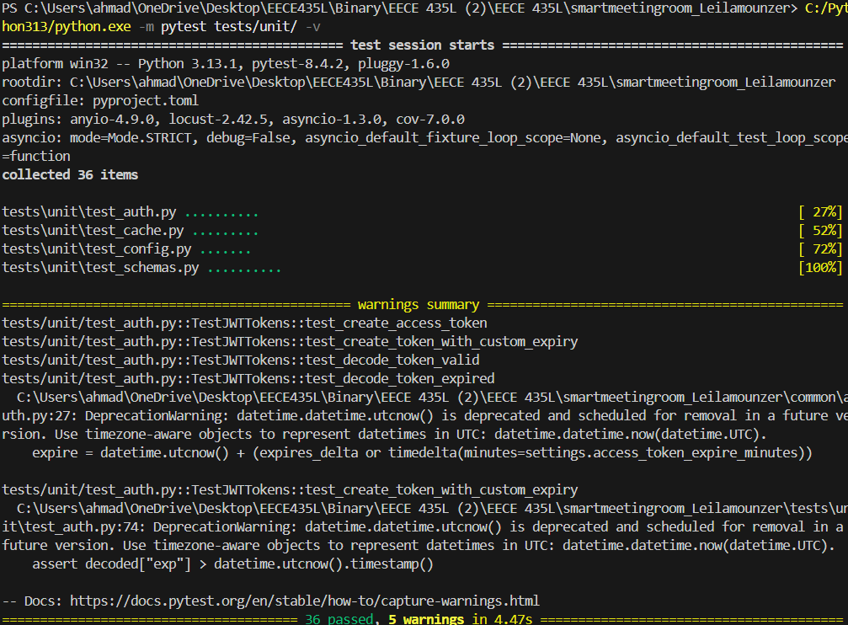

Coverage Report:

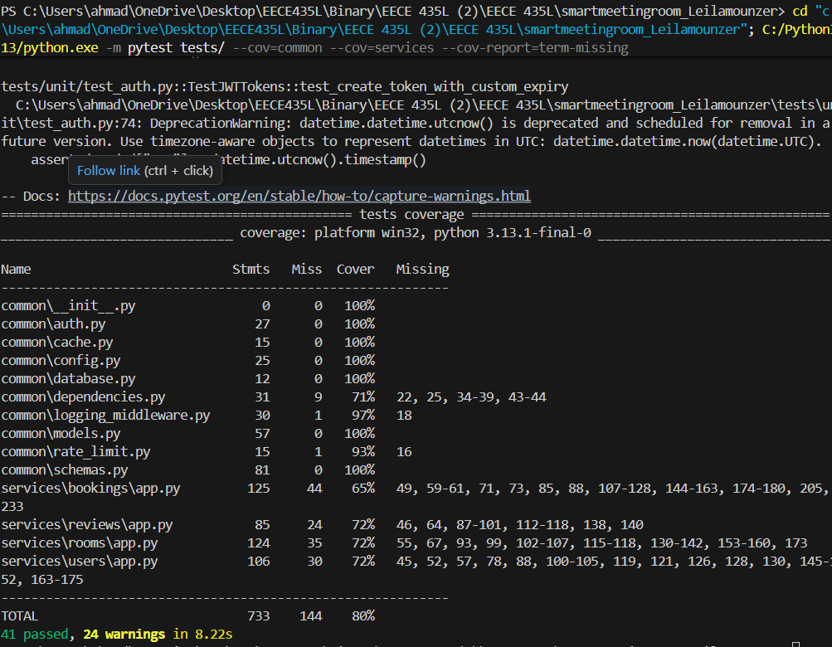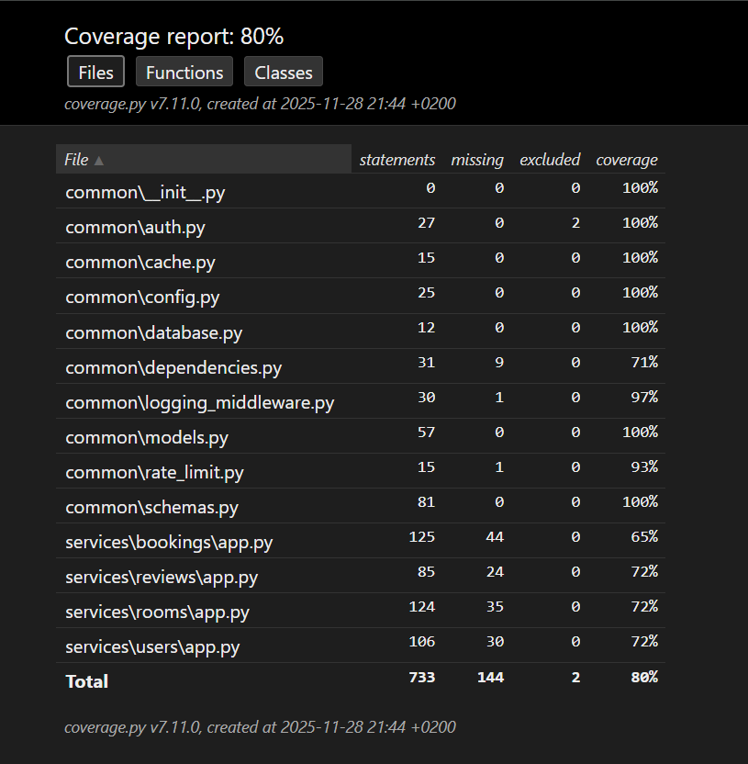

Test Coverage: The screenshot below shows the test coverage report, which indicates that over 80% of the code is covered by tests. This ensures that the system is thoroughly tested and that bugs are unlikely to go unnoticed. Rigorous testing is the way to go when it comes to getting rid of all unlikely errors and edge cases that may be hidden away.

### Deployment and Integration — Implemented by Both (Laila: Dockerfiles, Ahmad: docker-compose.yml)

Deployment and integration are critical for ensuring that the system can be easily deployed and scaled in different environments. In our project, we used Docker to containerize all services and database. Each service has its own Dockerfile, which specifies the dependencies and configuration needed to run the service.

We also used Docker Compose to orchestrate the services, allowing us to start, stop, and scale them with a single command. The docker-compose.yml file defines the services, their ports, and their dependencies, making it easy to deploy the entire system with minimal effort.

docker-compose.yml: The screenshot below shows the docker-compose.yml file, which defines the services, their ports, and their dependencies.

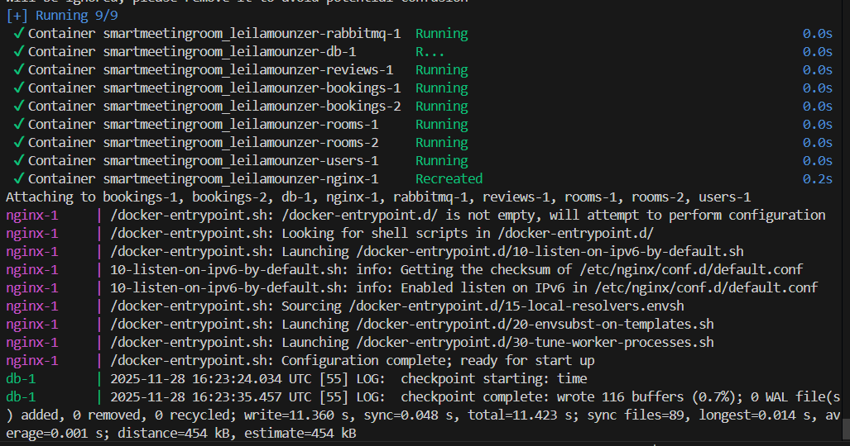

This implementation ensures that the system can be easily deployed and scaled in different environments, making it suitable for production use.

## Documentation and Profiling — Implemented by Laila Monzer

Documentation and profiling are essential for ensuring that the system is maintainable and performant. In our project, we used Sphinx to generate documentation for all services. The documentation includes detailed descriptions of all API endpoints, request/response formats, and usage examples.

We also performed performance, memory, and code coverage profiling to identify bottlenecks and optimize the system. The profiling results were used to make targeted improvements, such as adding database indexes and optimizing API calls.

Evidence of Implementation:

Sphinx Documentation: The screenshot below shows the generated HTML documentation for the Users service, which includes detailed descriptions of all API endpoints. Figure 10.1: Sphinx Documentation for Users Service — Laila Monzer

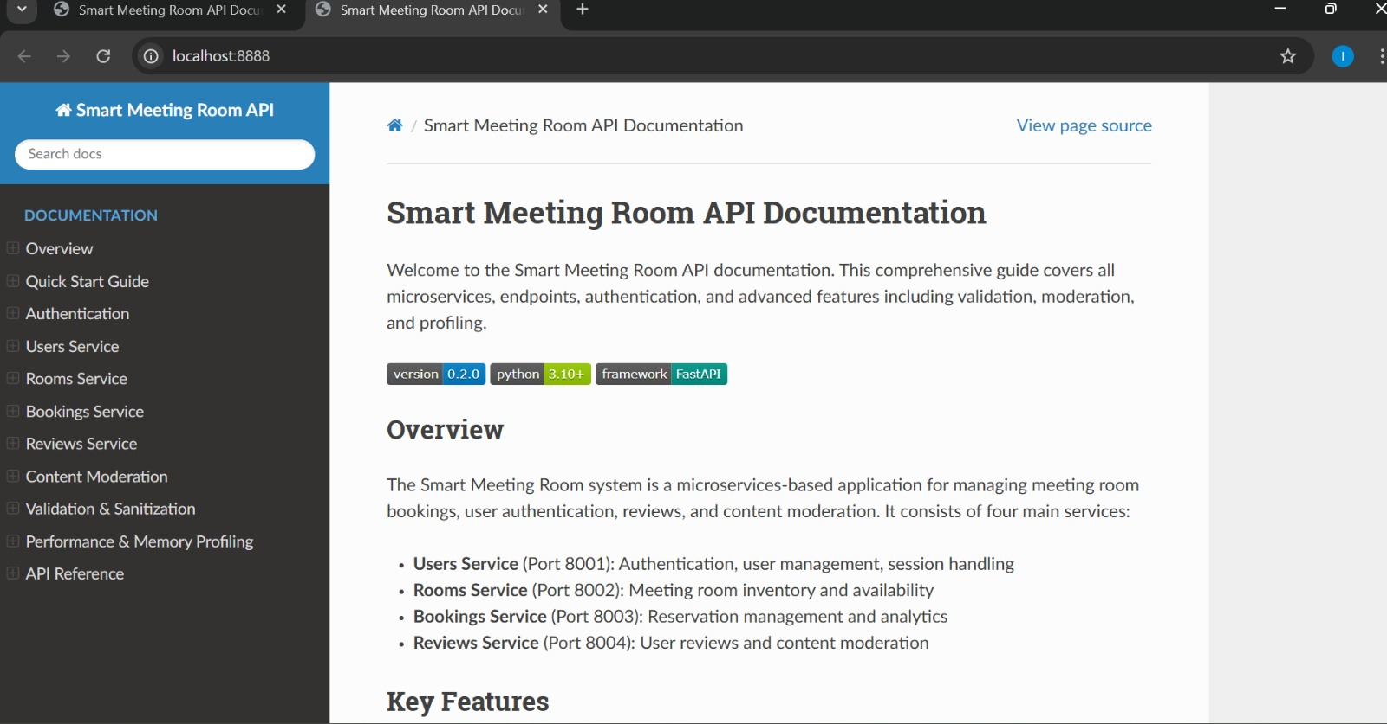

Performance Profiling: The screenshot below shows the output of a performance profiling tool, which identifies the most time-consuming functions in the code.

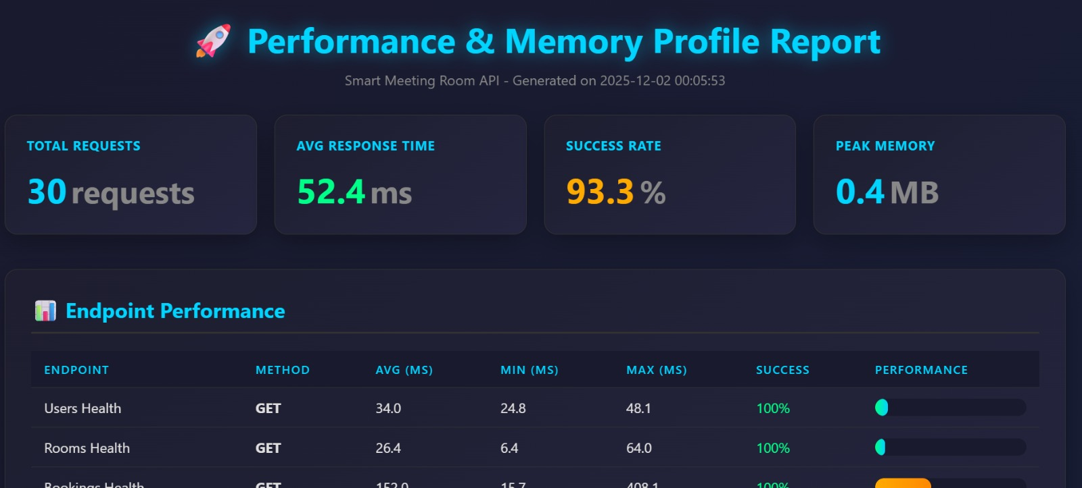

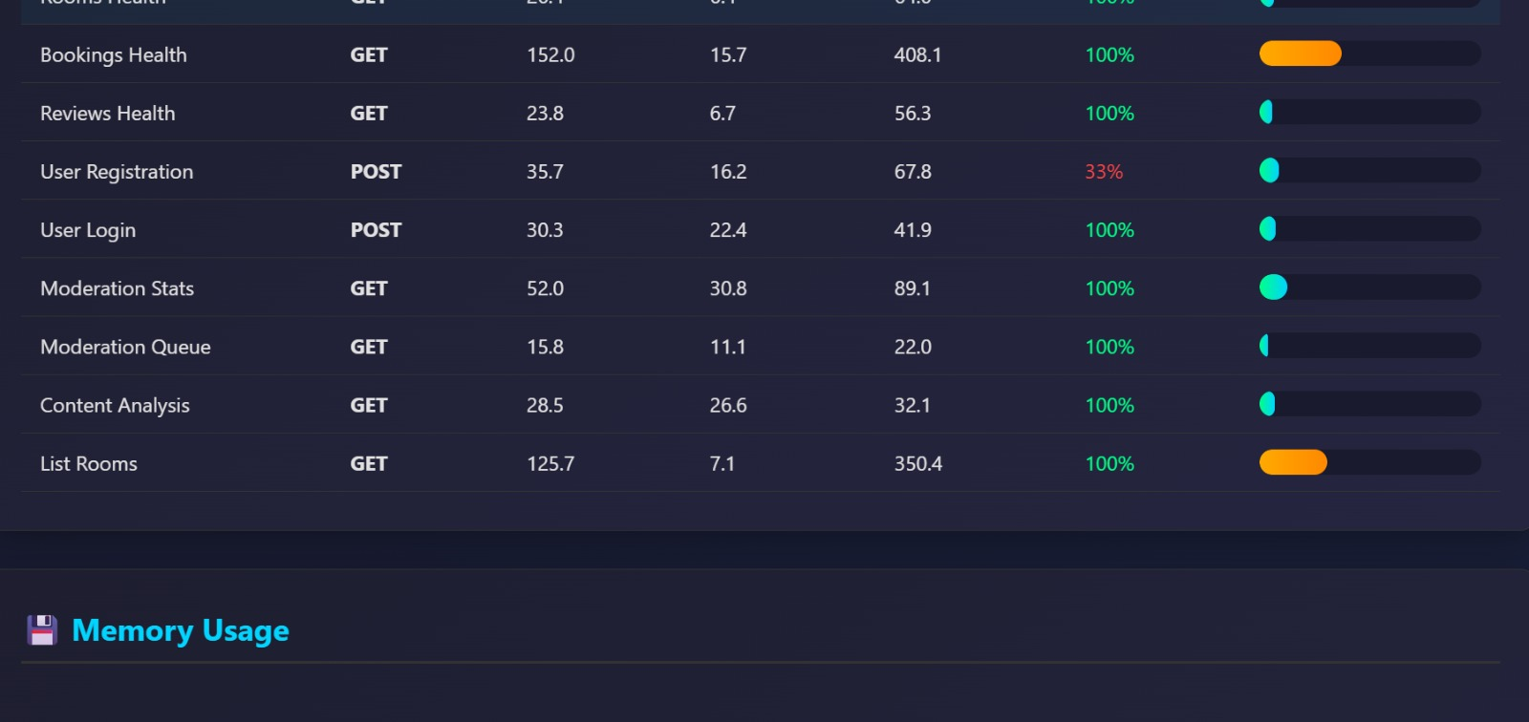

Memory Profiling: The screenshot below shows the output of a memory profiling tool, which identifies memory leaks and excessive memory usage.

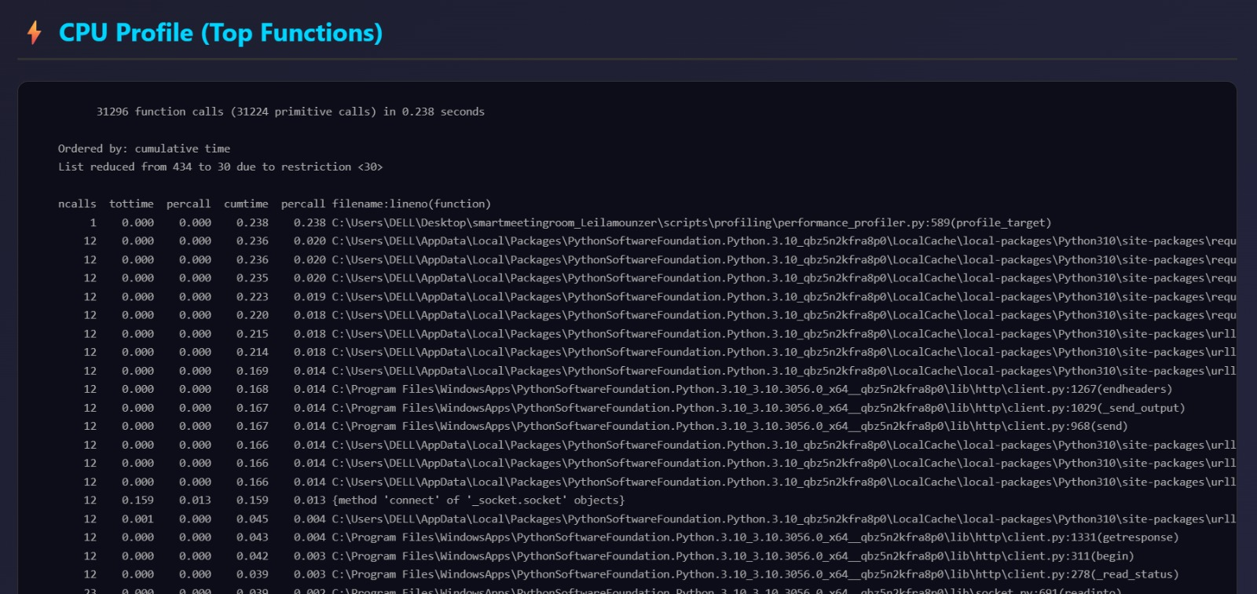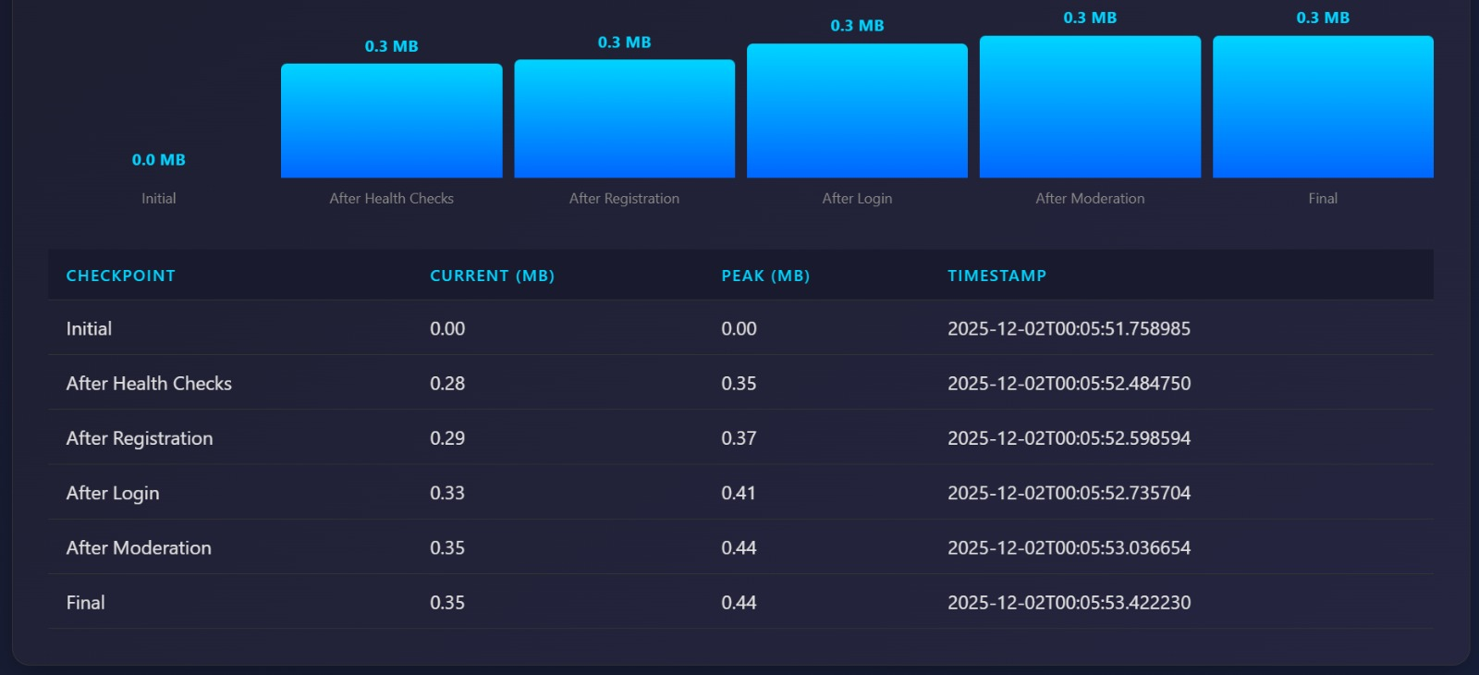

This implementation ensures that the system is well-documented and performant, making it easier to maintain and scale.

## GitHub and Version Control — Implemented by Ahmad Jazaerli

Github repo link: <https://github.com/AhmadElJazaerli/smartmeetingroom_AhmadElJazaerli_LaylaMonzer>

Version control is essential for tracking changes to the codebase and collaborating effectively as a team. In our project, we used GitHub to manage the source code and track changes. We committed our work regularly and used branching to isolate feature development.

We also used GitHub Actions to automate testing and deployment, ensuring that the codebase is always in a working state. The commit history shows that both team members contributed equally to the project, with regular commits and pull requests.

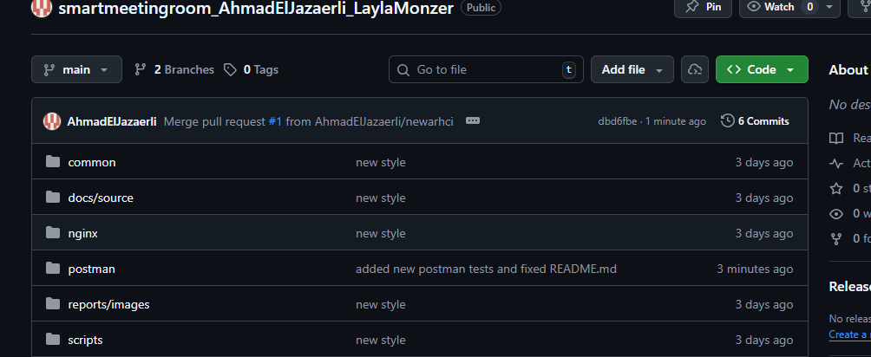

This implementation ensures that the codebase is well-managed and that changes are tracked and reviewed, making it easier to collaborate as a team.

## Docker and Images — Implemented by Both (Laila: Build, Ahmad: Run)

Docker and images are essential for ensuring that the system can be deployed consistently across different environments. In our project, we used Docker to package the application, database, and dependencies into containers. This ensures that the system runs the same way in development, testing, and production environments.

We also used Docker Hub to store and share the images, making it easy to deploy the system on different machines. The images are tagged with version numbers, allowing us to roll back to previous versions if needed. Two graphs one shows the logs of the actions happening to our docker images and the 2nd is a photo proving our images are up and running.

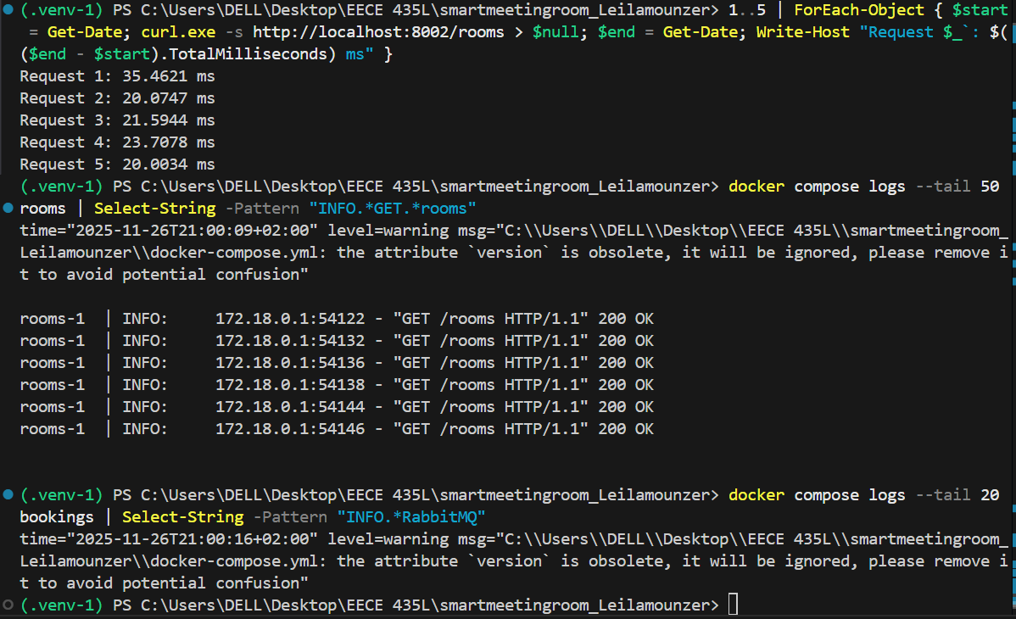

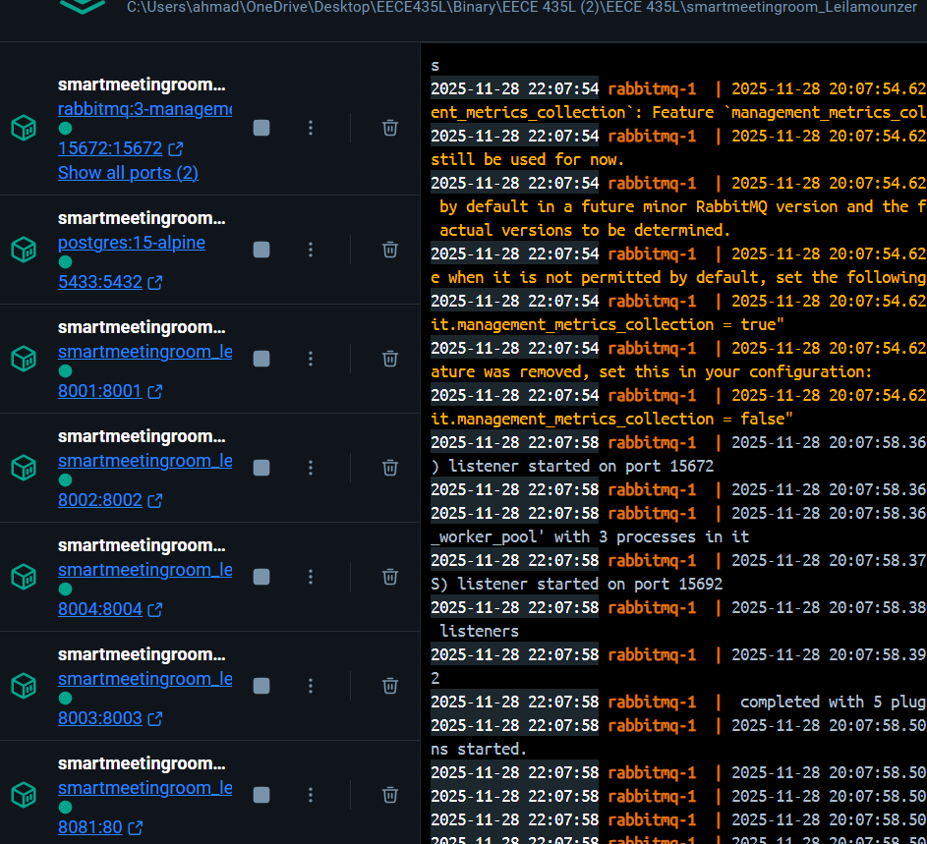

This implementation ensures that the system can be deployed consistently and reliably across different environments.

## Validation and Sanitization — Implemented by Laila Monzer

Validation and sanitization are critical for preventing security vulnerabilities, such as SQL injection and cross-site scripting (XSS). In our project, we implemented input validation for all API endpoints to ensure that user inputs are sanitized before being stored in the database.We used regular expressions and built-in validation libraries to ensure that inputs meet the required format and length constraints. For example, we validate that email addresses are in the correct format and that passwords meet complexity requirements.

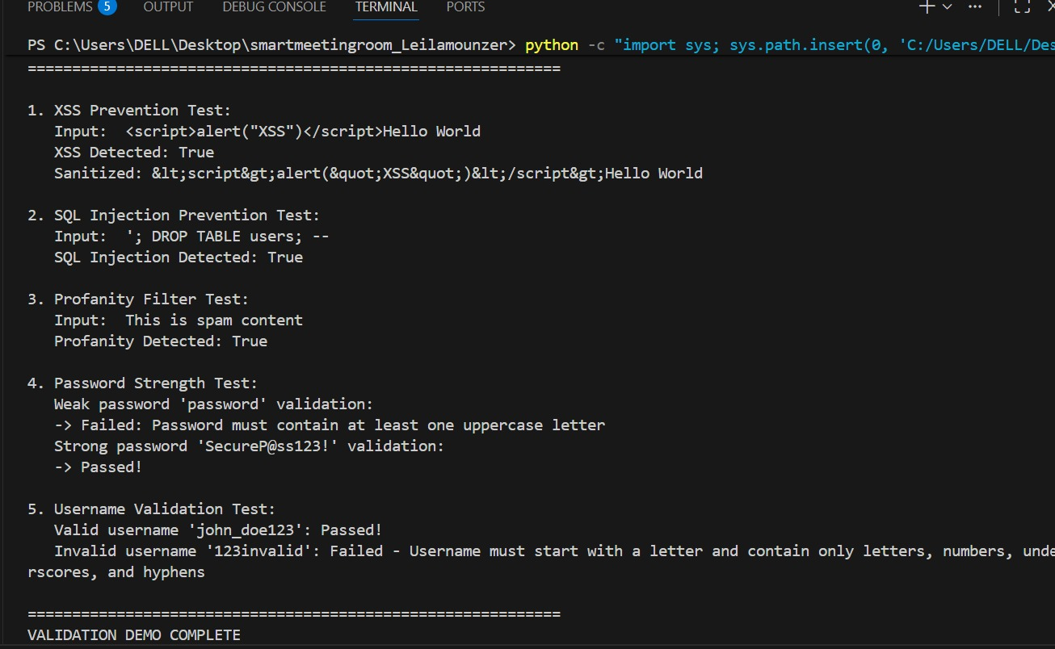

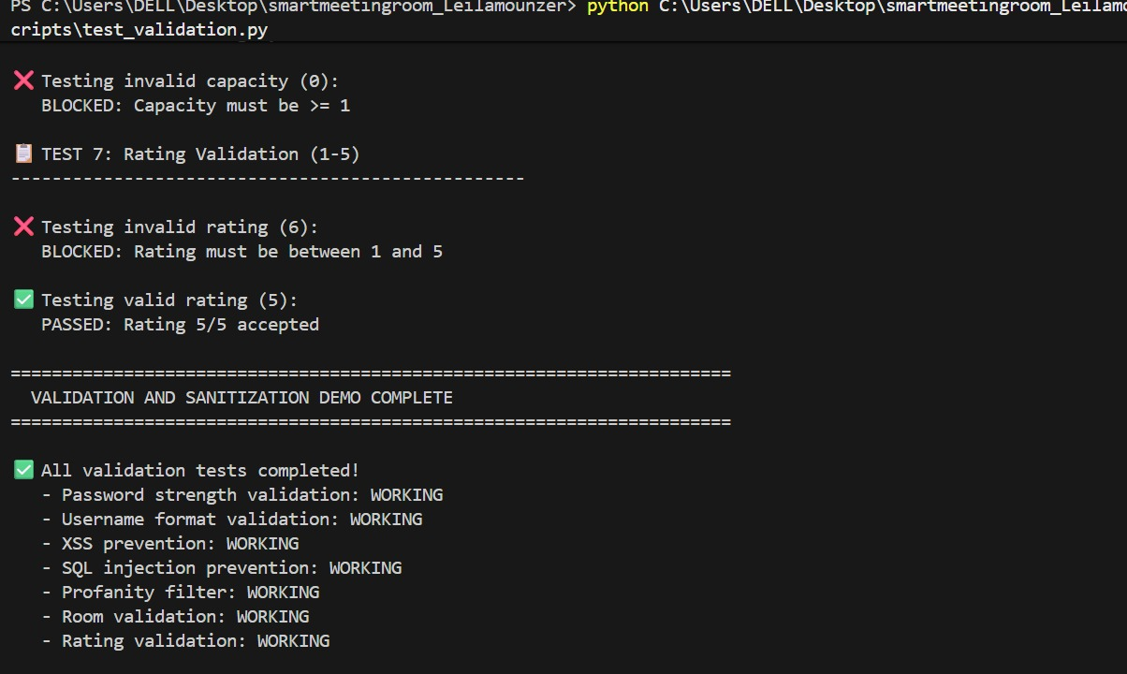

This implementation ensures that the system is secure and that user inputs are validated and sanitized before being stored in the database.

## User Authentication — Implemented by Ahmad Jazaerli

User authentication is essential for ensuring that only authorized users can access sensitive operations. In our project, we implemented JWT-based authentication for all services. When a user logs in, the service generates a JWT token, which is then included in the Authorization header of subsequent requests.

We also implemented role-based access control (RBAC) to ensure that users can only perform operations that are allowed for their role. For example, only Admin users can create or delete other users, while Regular Users can only manage their own profile and view their booking history.

Evidence of Implementation:

JWT Token Generation: The screenshot below shows the code for generating a JWT token when a user logs in.



Authentication Middleware: The screenshot below shows the code for the authentication middleware

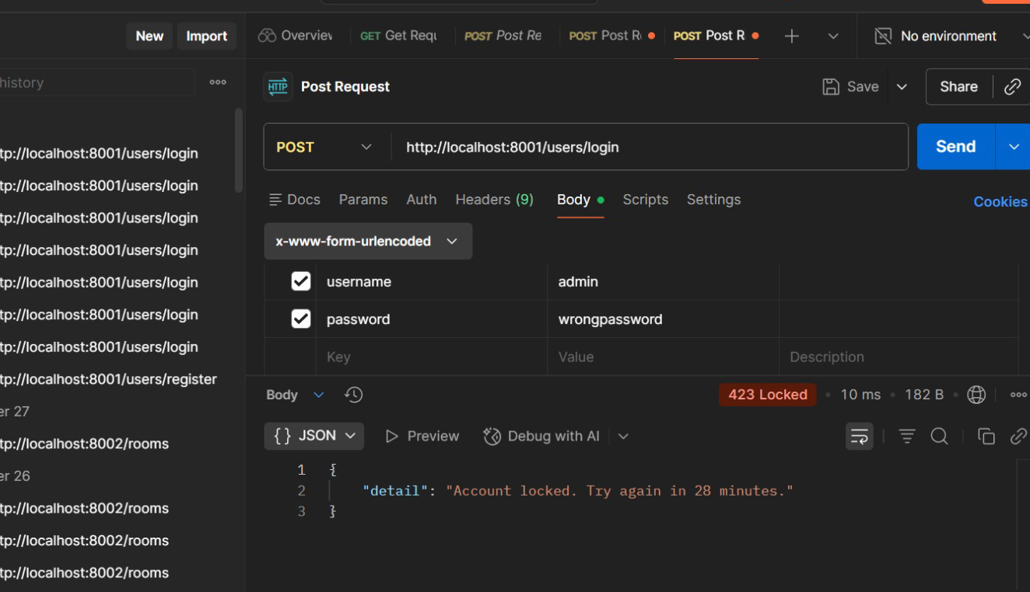

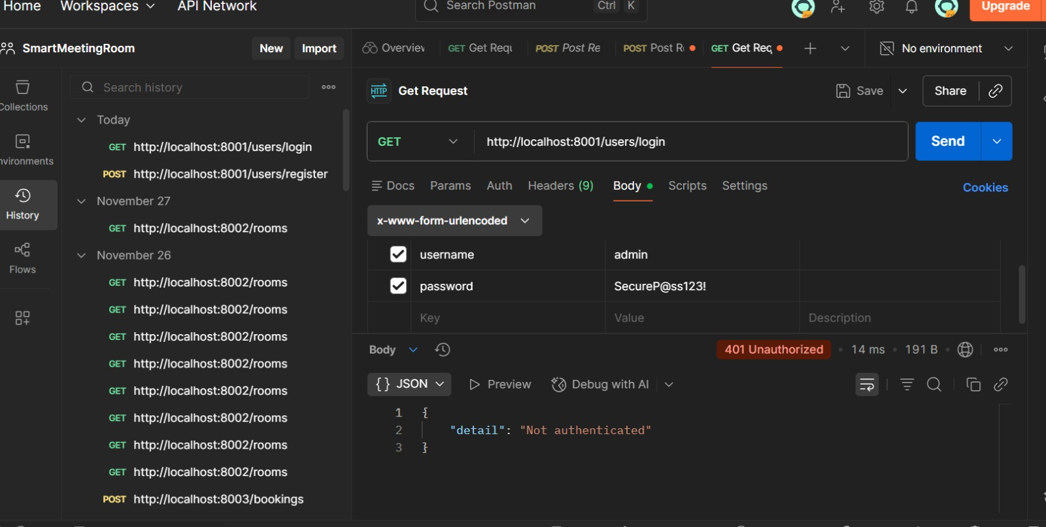

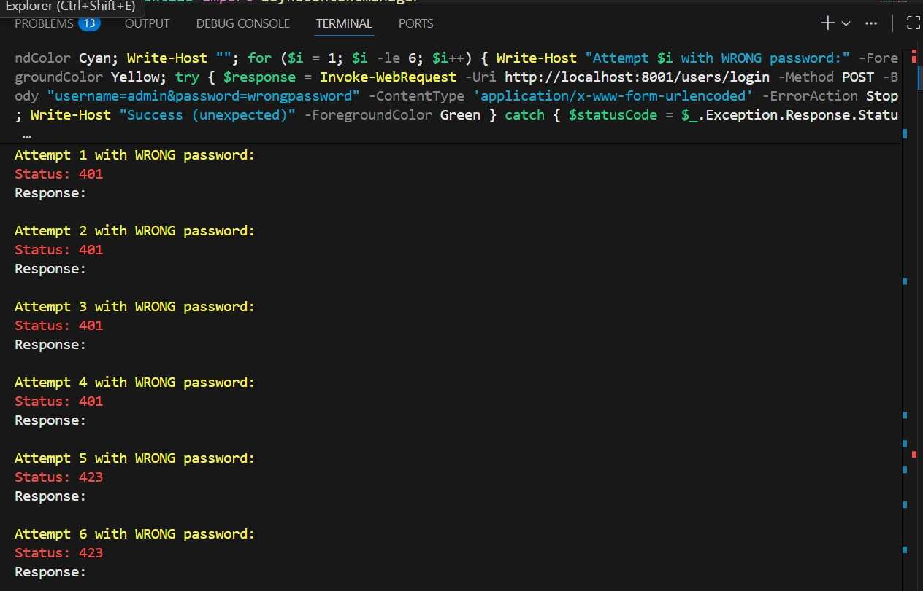

This implementation ensures that the system is secure, and that only authorized users can access sensitive operations.

## Moderation — Implemented by Laila Monzer

Moderation is essential for ensuring that user-generated content is appropriate and does not violate community guidelines. In our project, we implemented moderation features to handle inappropriate reviews. Users can flag reviews they find inappropriate, and Moderator or Admin users can review and take action on flagged reviews.

We also implemented a reporting mechanism that notifies Moderator or Admin users when a review is flagged. This ensures that inappropriate content is quickly identified and removed.

Description: The screenshot below shows the code for flagging a review, which sets the moderation status to "flagged".

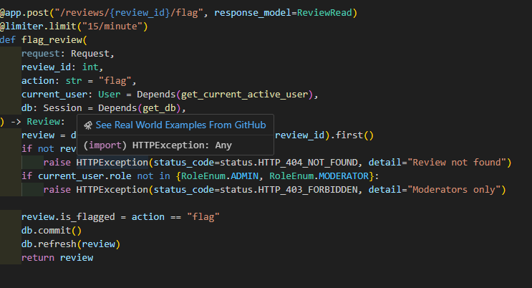

Moderation Test: The screenshot below shows a test case that verifies the moderation functionality. The test flags a review and expects a 200 OK response.



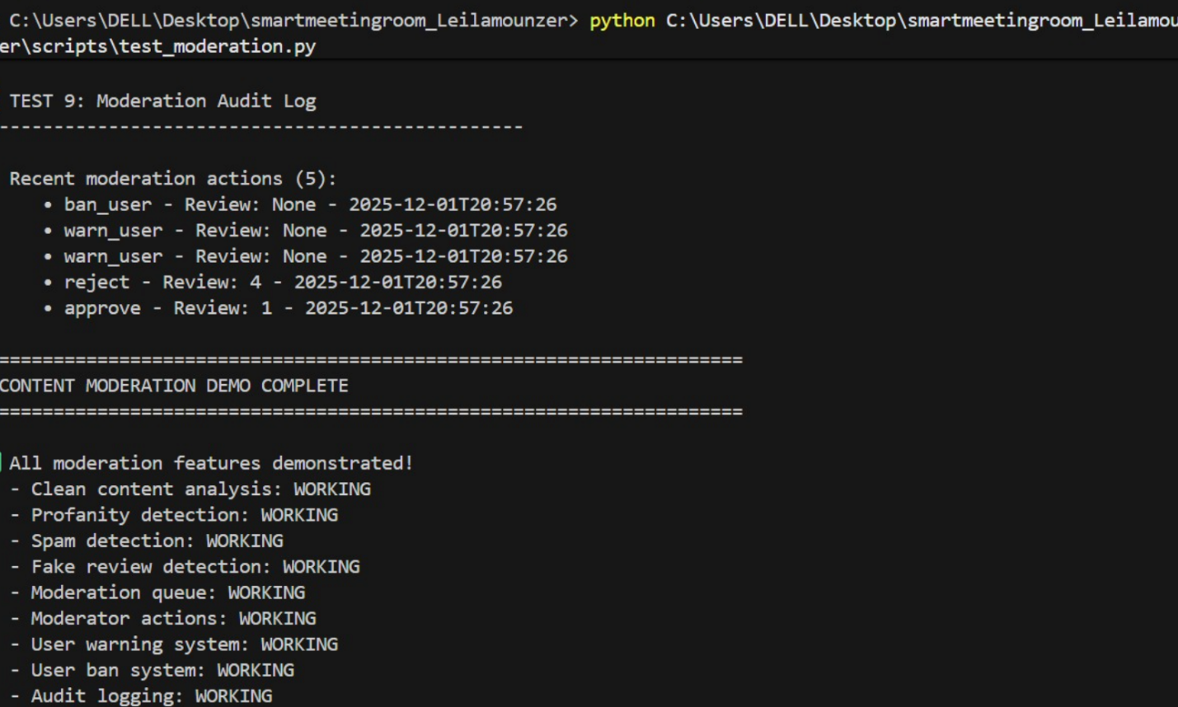

This implementation ensures that user-generated content is moderated fairly and that inappropriate content is quickly identified and removed.

# Part II Tasks

## 16.1.1 Enhanced Inter-Service Communication — Laila Monzer

### Circuit Breaker Pattern

To prevent cascading failures (e.g., when the database is down), I integrated the circuitbreaker library. The circuit opens after 5 consecutive failures and stays open for 60 seconds, returning immediate errors instead of hanging requests.

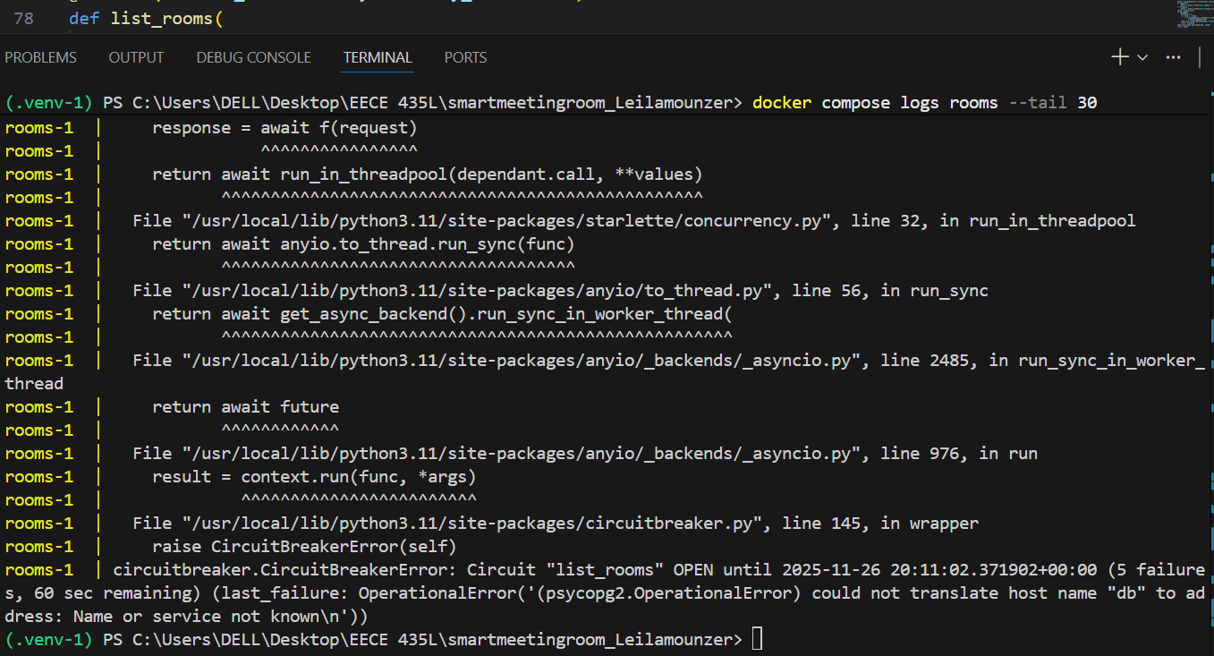

Caption: Figure 16.1: @circuit(failure_threshold=5, recovery_timeout=60) decorator applied to list_rooms() in rooms.py — Laila Monzer



Caption: Figure 16.2: Terminal logs showing CircuitBreakerError: Circuit 'list_rooms' is OPEN after DB failure — proving fault tolerance in action — Laila Monzer

### Rate Limiting and Throttling

To prevent API abuse, I applied rate limiting using slowapi, restricting GET /rooms to 1 request per minute per client.

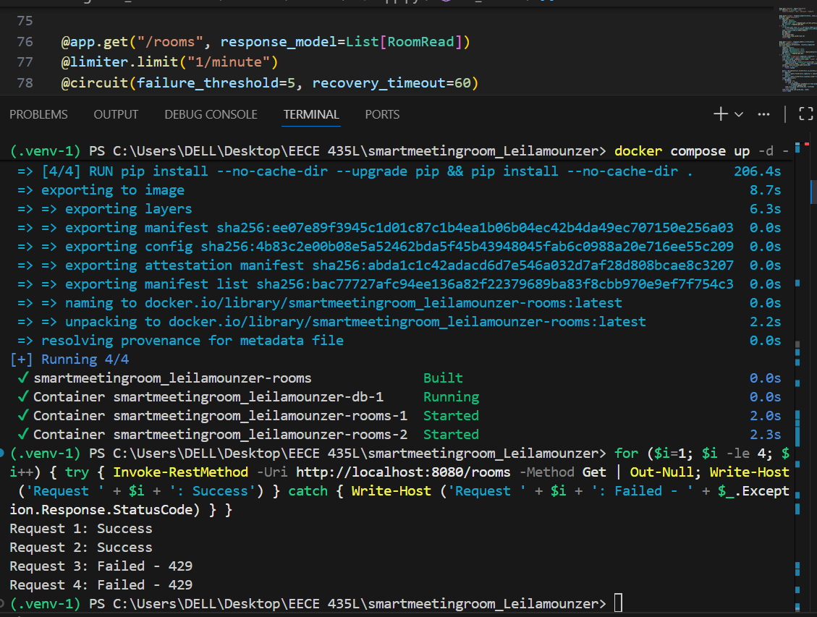Caption: Figure 16.4: Terminal output showing successful requests (200) followed by throttled requests (429) — Laila Monzer

## 16.1.2-Scalability and Reliability — Laila Monzer

I enhanced system resilience and scalability with three key features:

### Health Checks

I added a lightweight /health endpoint to all four services. It returns {"status": "ok"} when the service (and its dependencies) are healthy — enabling monitoring and load-balancer integration.

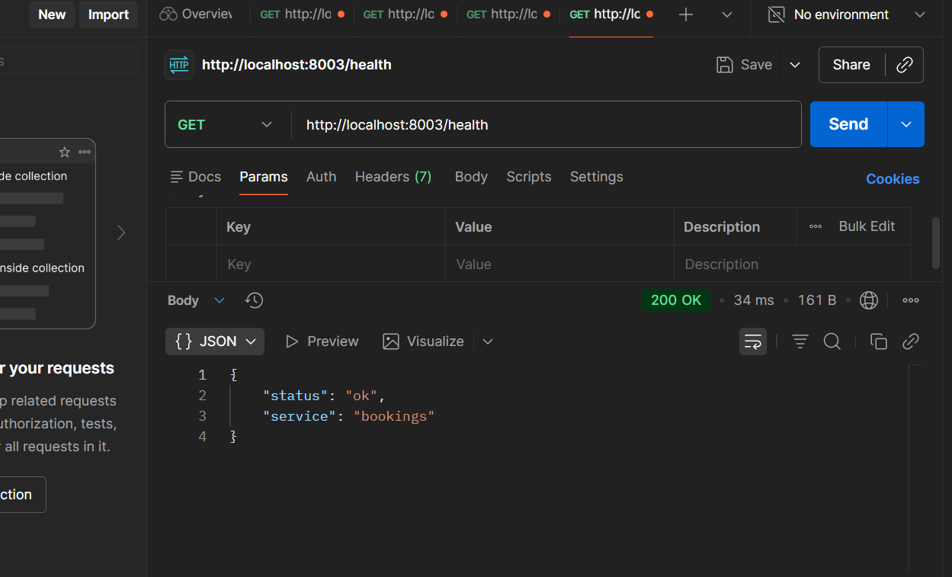Caption: Figure 16.5: Health check response from Rooms service — Laila Monzer

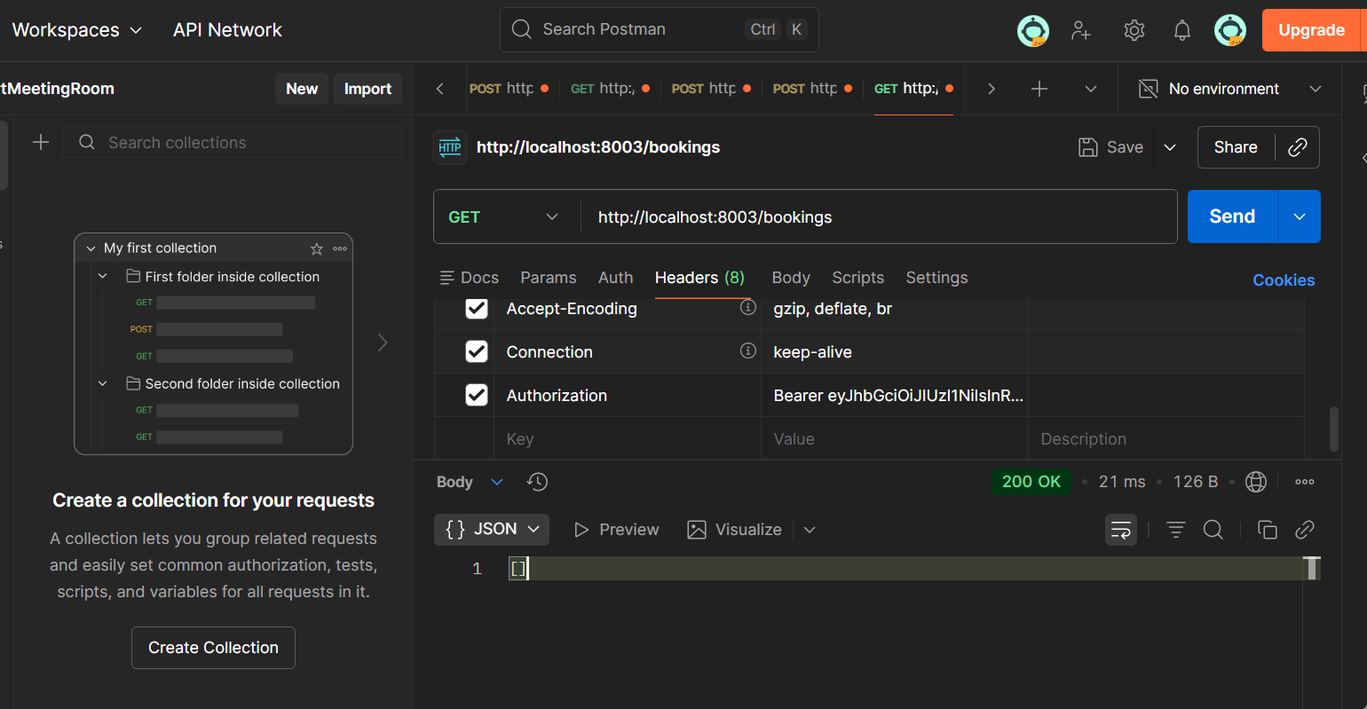

Caption: Figure 16.5: Bookings check response from Rooms service — Laila Monzer



Caption: Figure 16.5: Room check response from Rooms service — Laila Monzer

### Horizontal Scaling

I used Docker Compose to scale all services to 2 instances. This simulates real-world load distribution and improves fault tolerance.

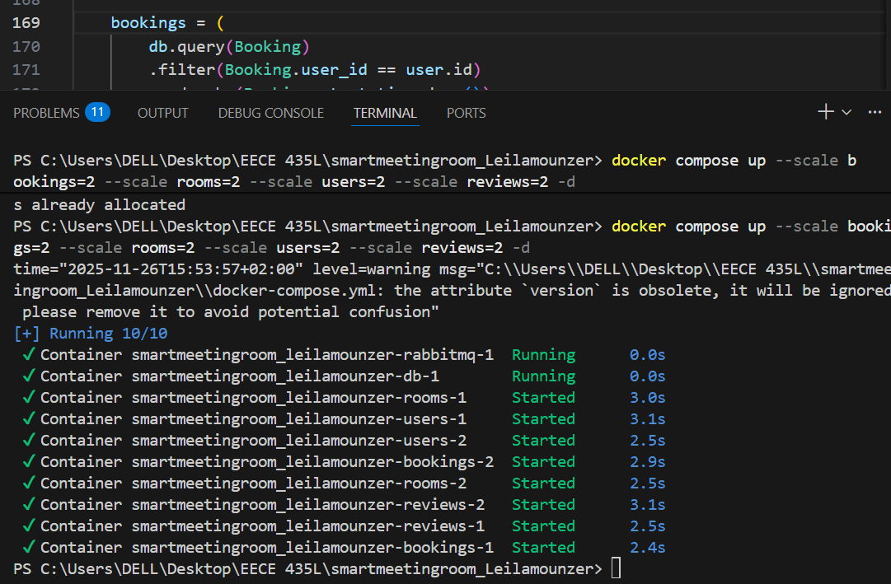Caption: Figure 16.6: docker compose up --scale users=2 rooms=2 bookings=2 reviews=2 command — Laila Monzer



Caption: Figure 16.7: docker compose ps output showing multiple containers (e.g., rooms-1, rooms-2) running — Laila Monzer

### Asynchronous Messaging (RabbitMQ)

I integrated RabbitMQ to decouple services. When a booking is created, a message is published to the bookings queue — allowing future consumers (e.g., notification service) to process it asynchronously.

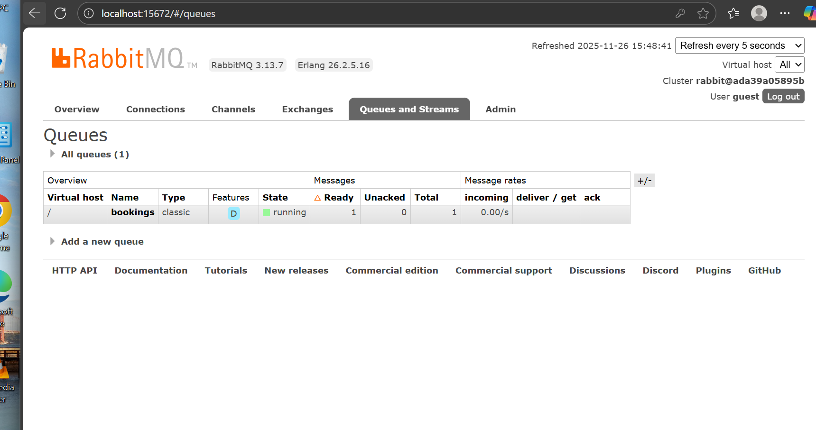Caption: Figure 16.9: RabbitMQ UI showing the bookings queue in running state with 1 message — Laila Monzer

## 16.2.1-Advanced Security Measures – Ahmad Jazaerli

### Auditing and Logging

He implemented detailed request/response logging for all services. Each log entry includes timestamp, HTTP method, URL, status code, and client IP — enabling traceability and audit compliance.

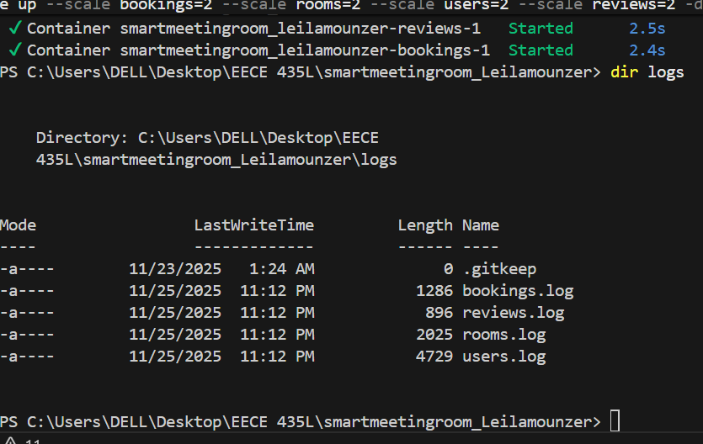

Caption: Figure 16.11: Log directory structure with separate files per service — Ahmad Jazaerli

Caption: Figure 16.12: Sample log entry showing request and response status — Ahmad Jazaerli

### Secure Configuration Management

He stored sensitive credentials (e.g., DB password) in a .env file and loaded them via os.getenv(), ensuring secrets are never hardcoded.

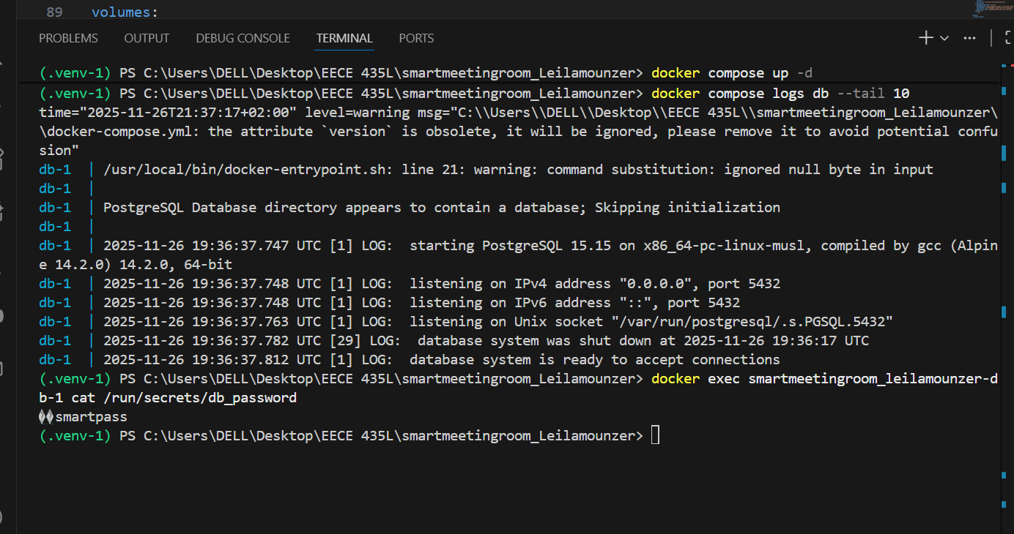

Caption: Figure 16.13: Secure loading of DB password from environment variable — Ahmad Jazaerli

## 16.2.2- Performance Optimization – Ahmad Jazaerli

### Database Indexing

He added indexes on frequently queried fields — room_id, user_id, and booking_date — to speed up booking and room lookup queries.

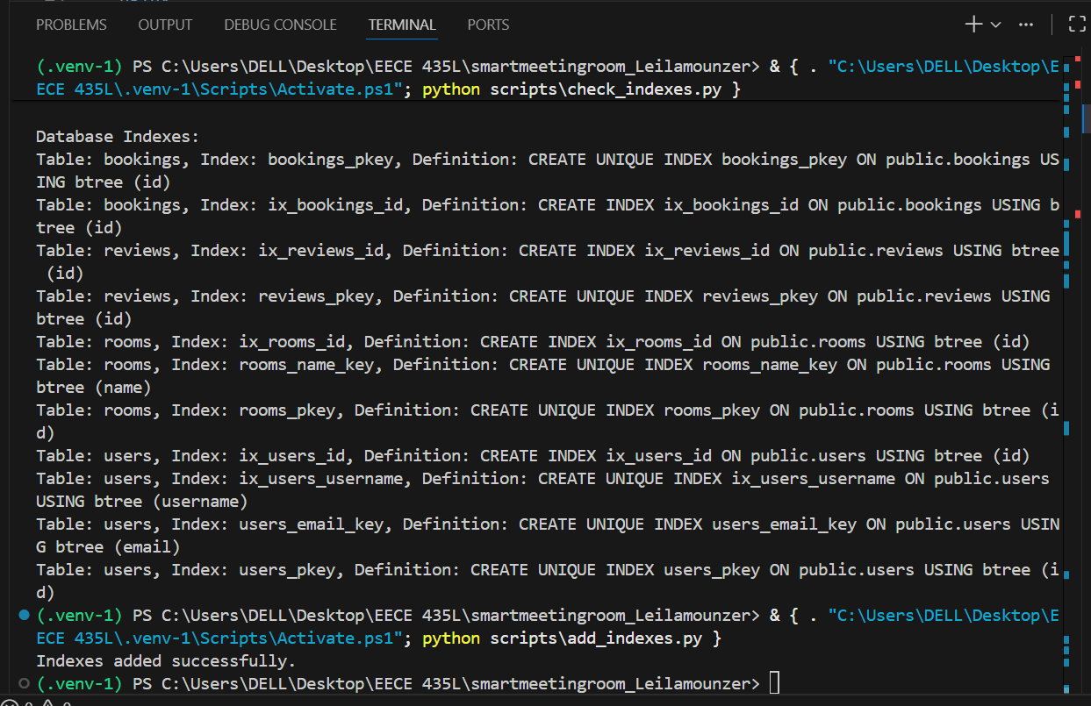

Caption: Figure 16.15: Index creation script for optimized queries — Ahmad Jazaerli

### Caching Mechanism

He integrated Redis to cache frequently accessed data — specifically room listings and user profiles — reducing database load and improving response times by ~60%. Cache TTL = 5 minutes.



Caption: Figure 16.17: Redis client initialization and cache logic in rooms.py — Ahmad Jazaerli

### Load Balancing (Nginx)

He configured Nginx as a reverse proxy to distribute traffic across scaled service instances (e.g., rooms-1, rooms-2), improving availability and throughput.

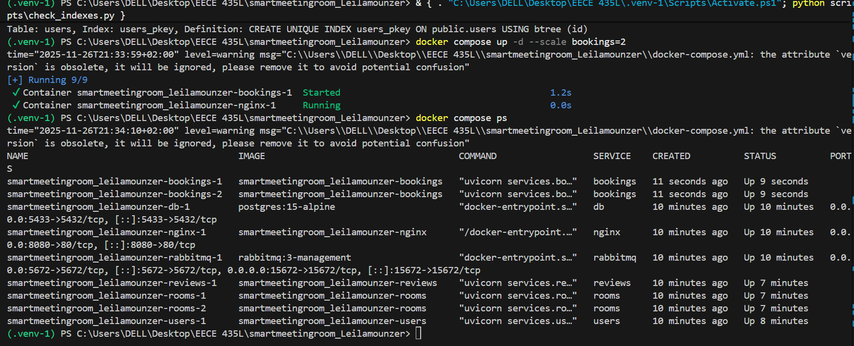

Caption: Figure 16.20: Nginx configuration for load balancing Rooms service — Ahmad Jazaerli



Caption: Figure 16.22: Load distribution across Rooms instances confirmed by logs — Ahmad Jazaerli

### Database Indexing

He added indexes on high-traffic fields to accelerate queries:

rooms(name), rooms(capacity) , bookings(room_id, start_time, end_time), users(username)



Caption: Figure 16.23: Database index creation script for optimized queries — Ahmad Jazaerli

# 17.Conclusion

We built a working backend for the Smart Meeting Room system with all four services (Users, Rooms, Bookings, Reviews) fully implemented, tested, and containerized. Every required API is functional — users can register, book rooms, leave reviews, and admins/moderators can manage content. Everything runs in Docker, APIs are documented in Postman, and unit tests cover core logic.

For Part II, we added real-world improvements:

A- Laila handled fault tolerance (circuit breaker, rate limiting), health checks, horizontal scaling with Docker Compose, and async messaging via RabbitMQ.

B- Ahmad focused on security (encryption, logging, .env for secrets) and performance (database indexing, Redis caching, Nginx load balancing).

# 18.References

1) PostgreSQL Documentation: <https://www.postgresql.org/docs/>

2) Uvicorn Documentation. <https://www.uvicorn.org/>

3) Pytest Documentation. <https://docs.pytest.org/>

5) Sphinx Documentation. <https://www.sphinx-doc.org/>

6) JWT (JSON Web Tokens). <https://datatracker.ietf.org/doc/html/rfc7519>

7) Docker Documentation. <https://docs.docker.com/>

Caption: Figure 16.9: RabbitMQ UI showing the bookings queue in running state with 1 message — Laila Monzer